








Provide arrival and departure assistance
D2.TTG.CL3.17
Trainer Guide

Provide arrival and departure assistance
D2.TTG.CL3.17
Trainer Guide





Project Base
William Angliss Institute of TAFE
555 La Trobe Street
Melbourne 3000 Victoria
Telephone: | (03) 9606 2111
Facsimile: | (03) 9670 1330
Acknowledgements
Project Director: | Wayne Crosbie
Project Manager | Jim Irwin
Chief Writer: | Alan Hickman
Subject Writer: | Nick Hyland
Editor: | Jim Irwin
DTP/Production: | Daniel Chee, Mai Vu, Cindy Curran

The Association of Southeast Asian Nations (ASEAN) was established on 8 August 1967. The Member States of the Association are Brunei Darussalam, Cambodia, Indonesia, Lao PDR, Malaysia, Myanmar, Philippines, Singapore, Thailand and Viet Nam.
The ASEAN Secretariat is based in Jakarta, Indonesia.
General Information on ASEAN appears online at the ASEAN Website: www.asean.org.
All text is produced by William Angliss Institute of TAFE for the ASEAN Project on “Toolbox Development for Tourism Labour Divisions for Travel Agencies and Tour Operations”.
This publication is supported by the Australian Government’s aid program through the ASEAN-Australia Development Cooperation Program Phase II (AADCP II).
Copyright: Association of Southeast Asian Nations (ASEAN) 2015.
All rights reserved.
Disclaimer
Every effort has been made to ensure that this publication is free from errors or omissions. However, you should conduct your own enquiries and seek professional advice before relying on any fact, statement or matter contained in this book. The ASEAN Secretariat and William Angliss Institute of TAFE are not responsible for any injury, loss or damage as a result of material included or omitted from this course. Information in this module is current at the time of publication. Time of publication is indicated in the date stamp at the bottom of each page.
Some images appearing in this resource have been purchased from stock photography suppliers Shutterstock and iStockphoto and other third party copyright owners and as such are non-transferable and non-exclusive. Clip arts, font images and illustrations used are from the Microsoft Office Clip Art and Media Library. Some images have been provided by and are the property of William Angliss Institute.
Additional images have been sourced from Flickr and SXC and are used under Creative Commons licence: http://creativecommons.org/licenses/by/2.0/deed.en
File name: TG_Provide_arrival_&_departure_assistance_150115





Table of contents
Competency Based Training (CBT) and assessment – An introduction for trainers 1
Competency standard 11
Notes and PowerPoint slides 23
Recommended training equipment 67
Instructions for Trainers for using PowerPoint – Presenter View 69
Appendix – ASEAN acronyms 71

Competency Based Training (CBT) and assessment – An introduction for trainers

Competency
Competency refers to the ability to perform particular tasks and duties to the standard of performance expected in the workplace.
Competency requires the application of specified knowledge, skills and attitudes relevant to effective participation, consistently over time and in the workplace environment.
The essential skills and knowledge are either identified separately or combined.
Knowledge identifies what a person needs to know to perform the work in an informed and effective manner.
Skills describe the application of knowledge to situations where understanding is converted into a workplace outcome.
Attitude describes the founding reasons behind the need for certain knowledge or why skills are performed in a specified manner.
Competency covers all aspects of workplace performance and involves:
- Performing individual tasks
- Managing a range of different tasks
- Responding to contingencies or breakdowns
- Dealing with the responsibilities of the workplace
- Working with others.

Unit of competency
Like with any training qualification or program, a range of subject topics are identified that focus on the ability in a certain work area, responsibility or function.
Each manual focuses on a specific unit of competency that applies in the hospitality workplace.
In this manual a unit of competency is identified as a ‘unit’.
Each unit of competency identifies a discrete workplace requirement and includes:
- Knowledge and skills that underpin competency
- Language, literacy and numeracy
- Occupational safety and health requirements.
Each unit of competency must be adhered to in training and assessment to ensure consistency of outcomes.

Element of competency
An element of competency describes the essential outcomes within a unit of competency.
The elements of competency are the basic building blocks of the unit of competency. They describe in terms of outcomes the significant functions and tasks that make up the competency.
In this manual elements of competency are identified as an ‘element’.

Performance criteria
Performance criteria indicate the standard of performance that is required to demonstrate achievement within an element of competency. The standards reflect identified industry skill needs.
Performance criteria will be made up of certain specified skills, knowledge and attitudes.

Learning
For the purpose of this manual learning incorporates two key activities:
- Training
- Assessment.
Both of these activities will be discussed in detail in this introduction.
Today training and assessment can be delivered in a variety of ways. It may be provided to participants:
- On-the-job – in the workplace
- Off-the-job – at an educational institution or dedicated training environment
- As a combination of these two options.
No longer is it necessary for learners to be absent from the workplace for long periods of time in order to obtain recognised and accredited qualifications.

Learning approaches
This manual will identify two avenues to facilitate learning:
Competency Based Training (CBT)
This is the strategy of developing a participant’s competency.
Educational institutions utilise a range of training strategies to ensure that participants are able to gain the knowledge and skills required for successful:
- Completion of the training program or qualification
- Implementation in the workplace.
The strategies selected should be chosen based on suitability and the learning styles of participants.

Competency Based Assessment (CBA)
This is the strategy of assessing competency of a participant.
Educational institutions utilise a range of assessment strategies to ensure that participants are assessed in a manner that demonstrates validity, fairness, reliability, flexibility and fairness of assessment processes.

Flexibility in learning
It is important to note that flexibility in training and assessment strategies is required to meet the needs of participants who may have learning difficulties. The strategies used will vary, taking into account the needs of individual participants with learning difficulties. However they will be applied in a manner which does not discriminate against the participant or the participant body as a whole.
Catering for participant diversity
Participants have diverse backgrounds, needs and interests. When planning training and assessment activities to cater for individual differences, trainers and assessors should:
- Consider individuals’ experiences, learning styles and interests
- Develop questions and activities that are aimed at different levels of ability
- Modify the expectations for some participants
- Provide opportunities for a variety of forms of participation, such as individual, pair and small group activities
- Assess participants based on individual progress and outcomes.
The diversity among participants also provides a good reason for building up a learning community in which participants support each other’s learning.
Participant centred learning
This involves taking into account structuring training and assessment that:
- Builds on strengths – Training environments need to demonstrate the many positive features of local participants (such as the attribution of academic success to effort, and the social nature of achievement motivation) and of their trainers (such as a strong emphasis on subject disciplines and moral responsibility). These strengths and uniqueness of local participants and trainers should be acknowledged and treasured
- Acknowledges prior knowledge and experience – The learning activities should be planned with participants’ prior knowledge and experience in mind
- Understands learning objectives – Each learning activity should have clear learning objectives and participants should be informed of them at the outset. Trainers should also be clear about the purpose of assignments and explain their significance to participants
- Teaches for understanding – The pedagogies chosen should aim at enabling participants to act and think flexibly with what they know
- Teaches for independent learning – Generic skills and reflection should be nurtured through learning activities in appropriate contexts of the curriculum. Participants should be encouraged to take responsibility for their own learning
- Enhances motivation – Learning is most effective when participants are motivated. Various strategies should be used to arouse the interest of participants
- Makes effective use of resources – A variety of teaching resources can be employed as tools for learning
- Maximises engagement – In conducting learning activities, it is important for the minds of participants to be actively engaged
- Aligns assessment with learning and teaching – Feedback and assessment should be an integral part of learning and teaching
- Caters for learner diversity – Trainers should be aware that participants have different characteristics and strengths and try to nurture these rather than impose a standard set of expectations.
Active learning
The goal of nurturing independent learning in participants does not imply that they always have to work in isolation or solely in a classroom. On the contrary, the construction of knowledge in tourism and hospitality studies can often best be carried out in collaboration with others in the field. Sharing experiences, insights and views on issues of common concern, and working together to collect information through conducting investigative studies in the field (active learning) can contribute a lot to their eventual success.
Active learning has an important part to play in fostering a sense of community in the class. First, to operate successfully, a learning community requires an ethos of acceptance and a sense of trust among participants, and between them and their trainers. Trainers can help to foster acceptance and trust through encouragement and personal example, and by allowing participants to take risks as they explore and articulate their views, however immature these may appear to be. Participants also come to realise that their classmates (and their trainers) are partners in learning and solving.
Trainers can also encourage cooperative learning by designing appropriate group learning tasks, which include, for example, collecting background information, conducting small-scale surveys, or producing media presentations on certain issues and themes. Participants need to be reminded that, while they should work towards successful completion of the field tasks, developing positive peer relationships in the process is an important objective of all group work.

Competency Based Training (CBT)
Principle of Competency Based Training
Competency based training is aimed at developing the knowledge, skills and attitudes of participants, through a variety of training tools.
Training strategies
The aims of this curriculum are to enable participants to:
- Undertake a variety of subject courses that are relevant to industry in the current environment
- Learn current industry skills, information and trends relevant to industry
- Learn through a range of practical and theoretical approaches
- Be able to identify, explore and solve issues in a productive manner
- Be able to become confident, equipped and flexible managers of the future
- Be ‘job ready’ and a valuable employee in the industry upon graduation of any qualification level.
To ensure participants are able to gain the knowledge and skills required to meet competency in each unit of competency in the qualification, a range of training delivery modes are used.
Types of training
In choosing learning and teaching strategies, trainers should take into account the practical, complex and multi-disciplinary nature of the subject area, as well as their participant’s prior knowledge, learning styles and abilities.
Training outcomes can be attained by utilising one or more delivery methods:
Lecture/tutorial
This is a common method of training involving transfer of information from the trainer to the participants. It is an effective approach to introduce new concepts or information to the learners and also to build upon the existing knowledge. The listener is expected to reflect on the subject and seek clarifications on the doubts.
Demonstration
Demonstration is a very effective training method that involves a trainer showing a participant how to perform a task or activity. Through a visual demonstration, trainers may also explain reasoning behind certain actions or provide supplementary information to help facilitate understanding.
Group discussions
Brainstorming in which all the members in a group express their ideas, views and opinions on a given topic. It is a free flow and exchange of knowledge among the participants and the trainer. The discussion is carried out by the group on the basis of their own experience, perceptions and values. This will facilitate acquiring new knowledge. When everybody is expected to participate in the group discussion, even the introverted persons will also get stimulated and try to articulate their feelings.
The ideas that emerge in the discussions should be noted down and presentations are to be made by the groups. Sometimes consensus needs to be arrived at on a given topic. Group discussions are to be held under the moderation of a leader guided by the trainer. Group discussion technique triggers thinking process, encourages interactions and enhances communication skills.
Role play
This is a common and very effective method of bringing into the classroom real life situations, which may not otherwise be possible. Participants are made to enact a particular role so as to give a real feel of the roles they may be called upon to play. This enables participants to understand the behaviour of others as well as their own emotions and feelings. The instructor must brief the role players on what is expected of them. The role player may either be given a ready-made script, which they can memorize and enact, or they may be required to develop their own scripts around a given situation. This technique is extremely useful in understanding creative selling techniques and human relations. It can be entertaining and energizing and it helps the reserved and less literate to express their feelings.

Simulation games
When trainees need to become aware of something that they have not been conscious of, simulations can be a useful mechanism. Simulation games are a method based on "here and now" experience shared by all the participants. The games focus on the participation of the trainees and their willingness to share their ideas with others. A "near real life" situation is created providing an opportunity to which they apply themselves by adopting certain behaviour. They then experience the impact of their behaviour on the situation. It is carried out to generate responses and reactions based on the real feelings of the participants, which are subsequently analysed by the trainer.
While use of simulation games can result in very effective learning, it needs considerable trainer competence to analyse the situations.
Individual /group exercises
Exercises are often introduced to find out how much the participant has assimilated. This method involves imparting instructions to participants on a particular subject through use of written exercises. In the group exercises, the entire class is divided into small groups, and members are asked to collaborate to arrive at a consensus or solution to a problem.
Case study
This is a training method that enables the trainer and the participant to experience a real life situation. It may be on account of events in the past or situations in the present, in which there may be one or more problems to be solved and decisions to be taken. The basic objective of a case study is to help participants diagnose, analyse and/or solve a particular problem and to make them internalize the critical inputs delivered in the training. Questions are generally given at the end of the case study to direct the participants and to stimulate their thinking towards possible solutions. Studies may be presented in written or verbal form.
Field visit
This involves a carefully planned visit or tour to a place of learning or interest. The idea is to give first-hand knowledge by personal observation of field situations, and to relate theory with practice. The emphasis is on observing, exploring, asking questions and understanding. The trainer should remember to brief the participants about what they should observe and about the customs and norms that need to be respected.
Group presentation
The participants are asked to work in groups and produce the results and findings of their group work to the members of another sub-group. By this method participants get a good picture of each other's views and perceptions on the topic and they are able to compare them with their own point of view. The pooling and sharing of findings enriches the discussion and learning process.
Practice sessions
This method is of paramount importance for skills training. Participants are provided with an opportunity to practice in a controlled situation what they have learnt. It could be real life or through a make-believe situation.

Games
This is a group process and includes those methods that involve usually fun-based activity, aimed at conveying feelings and experiences, which are everyday in nature, and applying them within the game being played. A game has set rules and regulations, and may or may not include a competitive element. After the game is played, it is essential that the participants be debriefed and their lessons and experiences consolidated by the trainer.
Research
Trainers may require learners to undertake research activities, including online research, to gather information or further understanding about a specific subject area.

Competency Based Assessment (CBA)
Principle of Competency Based Assessment
Competency based assessment is aimed at compiling a list of evidence that shows that a person is competent in a particular unit of competency.
Competencies are gained through a multitude of ways including:
- Training and development programs
- Formal education
- Life experience
- Apprenticeships
- On-the-job experience
- Self-help programs.
All of these together contribute to job competence in a person. Ultimately, assessors and participants work together, through the ‘collection of evidence’ in determining overall competence.
This evidence can be collected:
- Using different formats
- Using different people
- Collected over a period of time.
The assessor who is ideally someone with considerable experience in the area being assessed, reviews the evidence and verifies the person as being competent or not.
Flexibility in assessment
Whilst allocated assessment tools have been identified for this subject, all attempts are made to determine competency and suitable alternate assessment tools may be used, according to the requirements of the participant.
The assessment needs to be equitable for all participants, taking into account their cultural and linguistic needs.
Competency must be proven regardless of:
- Language
- Delivery Method
- Assessment Method.
Assessment objectives
The assessment tools used for subjects are designed to determine competency against the ‘elements of competency’ and their associated ‘performance criteria’.
The assessment tools are used to identify sufficient:
- Knowledge, including underpinning knowledge
- Skills
- Attitudes
Assessment tools are activities that trainees are required to undertake to prove participant competency in this subject.
All assessments must be completed satisfactorily for participants to obtain competence in this subject. There are no exceptions to this requirement, however, it is possible that in some cases several assessment items may be combined and assessed together.
Types of assessment
Allocated Assessment Tools
There are a number of assessment tools that are used to determine competency in this subject:
- Work projects
- Written questions
- Oral questions
- Third Party Report
- Observation Checklist.
Instructions on how assessors should conduct these assessment methods are explained in the Assessment Manuals.
Alternative assessment tools
Whilst this subject has identified assessment tools, as indicated above, this does not restrict the assessor from using different assessment methods to measure the competency of a participant.
Evidence is simply proof that the assessor gathers to show participants can actually do what they are required to do.
Whilst there is a distinct requirement for participants to demonstrate competency, there are many and diverse sources of evidence available to the assessor.
Ongoing performance at work, as verified by a supervisor or physical evidence, can count towards assessment. Additionally, the assessor can talk to customers or work colleagues to gather evidence about performance.
A range of assessment methods to assess competency include:
- Practical demonstrations
- Practical demonstrations in simulated work conditions
- Problem solving
- Portfolios of evidence
- Critical incident reports
- Journals
- Oral presentations
- Interviews
- Videos
- Visuals: slides, audio tapes
- Case studies
- Log books
- Projects
- Role plays
- Group projects
- Group discussions
- Examinations.
Recognition of Prior Learning
Recognition of Prior Learning is the process that gives current industry professionals who do not have a formal qualification, the opportunity to benchmark their extensive skills and experience against the standards set out in each unit of competency/subject.
Also known as a Skills Recognition Audit (SRA), this process is a learning and assessment pathway which encompasses:
- Recognition of Current Competencies (RCC)
- Skills auditing
- Gap analysis and training
- Credit transfer.
Assessing competency
As mentioned, assessment is the process of identifying a participant’s current knowledge, skills and attitudes sets against all elements of competency within a unit of competency. Traditionally in education, grades or marks were given to participants, dependent on how many questions the participant successfully answered in an assessment tool.
Competency based assessment does not award grades, but simply identifies if the participant has the knowledge, skills and attitudes to undertake the required task to the specified standard.
Therefore, when assessing competency, an assessor has two possible results that can be awarded:
- Pass Competent (PC)
- Not Yet Competent (NYC).
Pass Competent (PC)
If the participant is able to successfully answer or demonstrate what is required, to the expected standards of the performance criteria, they will be deemed as ‘Pass Competent’ (PC).
The assessor will award a ‘Pass Competent’ (PC) if they feel the participant has the necessary knowledge, skills and attitudes in all assessment tasks for a unit.
Not Yet Competent’ (NYC)
If the participant is unable to answer or demonstrate competency to the desired standard, they will be deemed to be ‘Not Yet Competent’ (NYC).
This does not mean the participant will need to complete all the assessment tasks again. The focus will be on the specific assessment tasks that were not performed to the expected standards.
The participant may be required to:
a) Undertake further training or instruction
b) Undertake the assessment task again until they are deemed to be ‘Pass Competent’.

Competency standard
UNIT TITLE: PROVIDE ARRIVAL AND DEPARTURE ASSISTANCE |  |  |  | NOMINAL HOURS:30
UNIT NUMBER: D2.TTG.CL3.17
UNIT DESCRIPTOR: This unit deals with skills and knowledge required to deliver assistance to arriving and departing passengers, generally between transport terminals and other locations including accommodation venues
ELEMENTS AND PERFORMANCE CRITERIA | UNIT VARIABLE AND ASSESSMENT GUIDE
Element 1: Provide assistance for arrival passengers  - Check itinerary of arriving passengers to identify and action alterations as required  - Confirm transport arrangements, where applicable  - Greet passengers  - Provide local information to passengers  - Advise passengers regarding check-in procedures at accommodation venues, where appropriate  - Direct passengers to appropriate transport location for transfer  - Use terminal facilities to assist in meeting arriving passengers  - Record passenger arrivals and other comments  - Facilitate movement of baggage from terminal to meet passenger needs  - Follow lost baggage procedures, where required  - Liaise with staff from other businesses to facilitate passenger arrival at, and use of, their products and services  Element 2: Provide assistance for departure customers  - Check itinerary of departing passengers to identify and action alterations as required  - Organise the departure of passengers from their location  - Verify departing passengers using a departures list  - Facilitate movement of baggage from departing passenger location to terminal  - Advise departing passengers regarding legal and other procedures applying to their departure  - Solicit feedback from departing guests on products and services  - Facilitate check-in of departing passengers at the terminal | Unit Variables  The Unit Variables provide advice to interpret the scope and context of this unit of competence, allowing for differences between enterprises and workplaces. It relates to the unit as a whole and facilitates holistic assessment.  This unit applies to staff who deliver assistance to arriving and departing passengers, generally between transport terminals and other locations including accommodation venues, within the labour divisions of the hotel and travel industries and may include:  - Front Office  - Travel Agencies  - Tour Operation  Check itinerary of arriving passengers may be related to:  - Identifying names and carriers of incoming passengers  - Comparing known itinerary against known changes to scheduled transportation, such as delays, cancellations and re-routing  - Determining whether or not changes need to be made to scheduled transportation  - Contacting carriers to make appropriate changes on behalf of the passenger  Noting possible options for changes to scheduled transportation to present to passenger.  Confirm transport arrangements will include:  - Contacting carrier  - Verifying that scheduled transportation is confirmed by date, time and departure destination.  Greet passengers may include:  - Welcoming passengers  - Encouraging feelings of goodwill  - Building rapport with the passengers  - Employing appropriate interpersonal skills.  Provide local information may include:  - Supplying local map and set of tourism information brochures and leaflets  - Advising details of transfers from the terminal to the accommodation venue  - Providing details and arrangements regarding sight-seeing tours and side-trips that are included as part of the stop-over at this destination  - Explaining the local time, currency, exchange rates and money changing facilities  - Providing advice on tipping and the accommodation venue  - Advising on the layout of the local area, the accommodation venue and the immediate vicinity  - Providing an overview of destination information  - Providing verbal advice regarding specific needs, wants and preferences  - Advising passengers of options and making suggestions.  Advise passengers regarding check-in procedures may include:  - Providing venue details and information  - Explaining booking details  - Describing documentation required by the venue at check-in in relation to personal identification and security for the room  - Describing details of the check-in process including details of any pre-registration that has occurred  - Issuing vouchers, where applicable.  Accommodation may include:  - Hotels, motels and guest houses  - Resorts and bed and breakfast providers  - Caravan parks and camping grounds.  Transport location may include:  - Airports  - Bus and coach terminals  - Taxi ranks/stands  - Train stations  - Shipping ports.  Terminal facilities may include:  - Public address systems  - Airside access  - Designated group meeting areas  - Internal communication systems between terminal and parking facilities.  Record passenger arrivals may include:  - Using internally generated documentation, such as an Arrivals List, to verify actual arrival of passenger  - Noting time of arrival, where required  - Recording passengers who do not arrive as a No Show  - Including details of reason for No Show, where known  - Noting accompanying baggage for each passenger, where required.  Facilitate movement of baggage may include:  - Establishing transport arrangements for baggage  - Supervising the movement of baggage  - Matching movement of baggage to locations in accordance with schedules/passenger movement  - Using checking procedures to ensure the correct baggage is transported for the appropriate passenger, including baggage tagging and recording.  Follow lost baggage procedures may include:  - Recording details and description of baggage claimed to have been lost  - Capturing details of the passenger, including their next destination, duration at that location and immediate ongoing itinerary  - Conducting immediate search for the baggage  - Notifying other staff to involve them in the baggage search  - Apologising to passenger  - Providing passenger with host enterprise on-the-spot compensation, where applicable  - Advising passenger regarding claims procedure against the company  - Advising passenger regarding insurance claims, where applicable  - Advising passenger regarding applicable terms and conditions  - Comforting passenger.  Liaise with staff from other businesses may include:  - Notifying other businesses that passengers have arrived at the terminal and/or that they have departed the terminal en route to their business  - Providing group details as appropriate for individual business types, which may include names, numbers, age, profile, identified issues and requirements, baggage, time restrictions, and confirmation of payment/deposits already made.  Check itinerary of departing passengers may include:  - Identifying names of departing passengers and carriers  - Comparing known itinerary against known changes to scheduled transportation arrangements, such as delays, cancellations, re-routing  - Determining whether or not changes need to be made to scheduled transportation  - Contacting carriers to make appropriate changes on behalf of the passenger  - Noting possible options for changes to scheduled transportation to present to passenger  - Confirming with carriers that scheduled transportation arrangements still apply and are ‘good to go’.  Organise the departure of passengers from their location may include:  - Advising passengers of pick-up time for transfer from the accommodation venue, or other location  - Specifying the exact pick-up point  - Explaining personal identification needed for the transfer  - Liaising with the venue to minimise disruption to their standard operating procedures, including arrangements for pre-payment of stay to speed up check-out, payment of outstanding charges by tour captain rather than individual passengers, scheduling the transfer at a time that does not coincide with a busy time at the venue and if necessary, using agency staff to assist with procedures such as baggage handling  - Advising passengers to undertake standard departure checks, such as returning room keys, checking to ensure no items left in rooms, recovering items left in safety deposit boxes, checking to make sure they have tickets, passports and visas.  Verify departing passengers may include:  - Checking departing passengers against documentation, such as a Departures List and/or Passenger Manifests  - Confirming the identity of departing passengers  - Checking the documentation of departing passengers  - Passing on information regarding changes made to scheduled itinerary, including the reasons for those changes and the knock-on impacts, if any, those changes will have to other itinerary arrangements  - Confirming baggage details.  Facilitate movement of baggage from departing passenger location to terminal may include:  - Advising passengers of details in relation to their baggage for transportation/transfer, including identification, security, maximum allowable and weight limitations  - Identifying the location where baggage is to be placed for pick-up  - Making arrangements with baggage carriers  - Making payments, as applicable  - Encouraging passengers to check rooms to ensure no baggage is left behind  - Making physical inspections of sites to check for baggage  - Using bag tags to identify baggage by passenger.  Advise departing passengers may include:  - Providing information regarding departure and other similar host country government requirements  - Assisting passengers in relation to their duty free entitlements and other arrangements, such as claiming back the Goods and Services Tax (GST) for monies spent within the country  - Assisting with advice in relation to completing out-going passenger cards and general procedures applicable at the terminal  - Describing security related requirements, including restrictions on items that may be packed and carried  - Providing information and advice regarding their next destination  Feedback from departing guests may include:  - Verbal or written feedback  - Formal and informal feedback  - Notifying passengers of post tour options for providing feedback.  Facilitate check-in of departing passengers may include:  - Organising terminal facilities to support efficient group departure, including arranging for extra staff such as interpreters, sufficient trolleys, putting barriers and tapes in place to create appropriate lane marking and meeting spaces/areas for incoming group transfers for check-in prior to departure  - Notifying carriers of verification of passenger details based on data captured during transfer from accommodation to terminal  - Pre-preparing departure documentation and procedures to the greatest extent possible prior to check-in of departing passengers  - Verifying with passengers that they have, or have completed, the required documentation to facilitate their departure  - Verifying and assisting passengers in complying with host country or carrier departure requirements.  Assessment Guide  The following skills and knowledge must be assessed as part of this unit:  - Enterprise policies and procedures in regard to delivering arrival and departure assistance to passengers  - Knowledge of the host country legislation, regulations and requirements in relation to arriving and departing travellers, including knowledge of payments due for inbound and outbound passenger movement  - Principles of customer service, group dynamics and group control  - Ability to use mass and individual communication techniques, including microphone and public address systems  - Ability to demonstrate conflict resolution, leadership, negotiation and problem solving skills  - Knowledge of industry documentation and terminology related to passengers, travellers and transfers  - Knowledge of local area, including products and services available and the location of same  - Knowledge of inbound and outbound carrier requirements, including timelines, notification requirements, terms and conditions and standard operating procedures  - Knowledge of support service providers, their contact details and the limitations of what they can do/provide  - Knowledge of baggage handling procedures at the terminal and associated accommodation venues  - Knowledge of the layout of the point of arrival and departure and facilities available, within the terminal.  Linkages To Other Units  - Manage and execute a detailed tour itinerary  - Source and present information  - Communicate on the telephone  - Develop and update local knowledge  - Work effectively with colleagues and customers  - Work in a socially diverse environment  - Maintain quality customer/guest service  - Develop and update tourism industry knowledge  - Promote products and services to customers  - Operate an automated information system  - Conduct pre-departure checks  - Maintain contacts with handling agents.  Critical Aspects of Assessment  Evidence of the following is essential:  - Understanding of host enterprise policies and procedures in regard to delivering arrival and departure assistance to passengers  - Understanding of the host country legislation, regulations and requirements in relation to arriving and departing travellers, including knowledge of payments due for inbound and outbound passenger movement  - Demonstrated ability to meet and facilitate the arrival and transfer of a designated group of passengers accompanied by baggage, at a nominated terminal to an identified accommodation venue, responding appropriately and effectively to questions and issues arising, and providing necessary local knowledge and accommodation venue-related information to optimise the likelihood of an enjoyable stay  - Demonstrated ability to notify a designated group of passengers of requirements in relation to their transfer, including baggage, from a nominated accommodation venue to a nominated terminal and oversee their departure by advising them of legal, cost-related and procedural requirements in relation to specified out-bound methods of travel.  Context of Assessment  Assessment must ensure:  - Actual or simulated workplace application of the provision of assistance and advice to in-bound and out-bound passengers.  Resource Implications  Training and assessment must include the use of real facilities, real people and real carriers, service providers and venues in real or simulated contexts; and access to workplace standards, procedures, policies, guidelines, tools and equipment. Note: lost baggage events may be simulated.  Assessment Methods  The following methods may be used to assess competency for this unit:  - Observation of practical candidate performance  - Role plays  - Portfolio of materials, including information kits and brochures supplied to in-bound and/or out-bound passengers, completed arrivals and departures lists and lost baggage forms  - Interviews with passengers, carriers and associated providers regarding their satisfaction with candidate performance  - Oral and written questions  - Third party reports completed by a supervisor  - Project and assignment work.
Key Competencies in this Unit
Level 1 = competence to undertake tasks effectively
Level 2 = competence to manage tasks
Level 3 = competence to use concepts for evaluating
 | Key Competencies | Level | Examples
 | Collecting, organising and analysing information | 2 | Review information on in-coming and departing passengers to serve as the basis for practical action
 | Communicating ideas and information | 1 | Distribute hard copy local information and provide verbal responses to questions
 | Planning and organising activities | 1 | Arrange group transfers and baggage movement between terminal and accommodation venues and return, where applicable
 | Working with others and in teams | 2 | Liaise with carriers and providers to organise and facilitate service provision
 | Using mathematical ideas and techniques | 1 | Calculate charges and fees; count baggage
 | Solving problems | 2 | Arrange amended travel arrangements where delays and cancellations occur
 | Using technology | 1 | Use communication equipment; retrieve information from computerised systems

Notes and PowerPoint slides
Slide
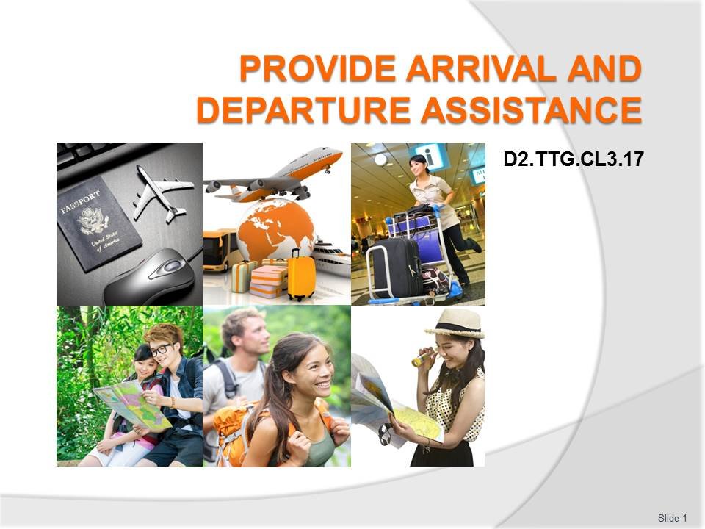
Slide No | Trainer Notes
 | Trainer welcomes students to class.

Slide
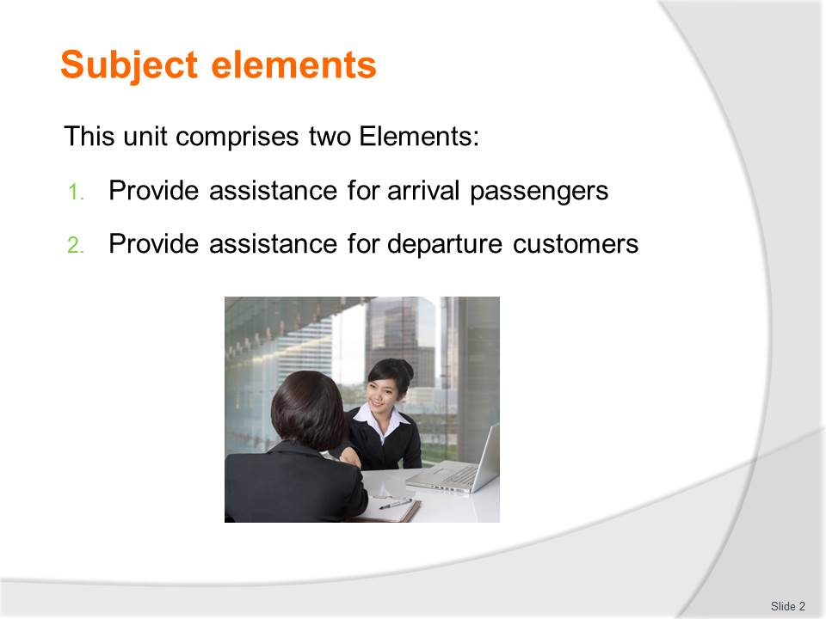
Slide No | Trainer Notes
Trainer advises this Unit comprises two Elements, as listed on the slide explaining:
- Each Element comprises a number of Performance Criteria which will be identified throughout the class and explained in detail
- Trainees can obtain more detail from their Trainee Manual
- At times the course presents advice and information about various protocols but where their workplace requirements differ to what is presented, the workplace practices and standards, as well as policies and procedures must be observed.

Slide
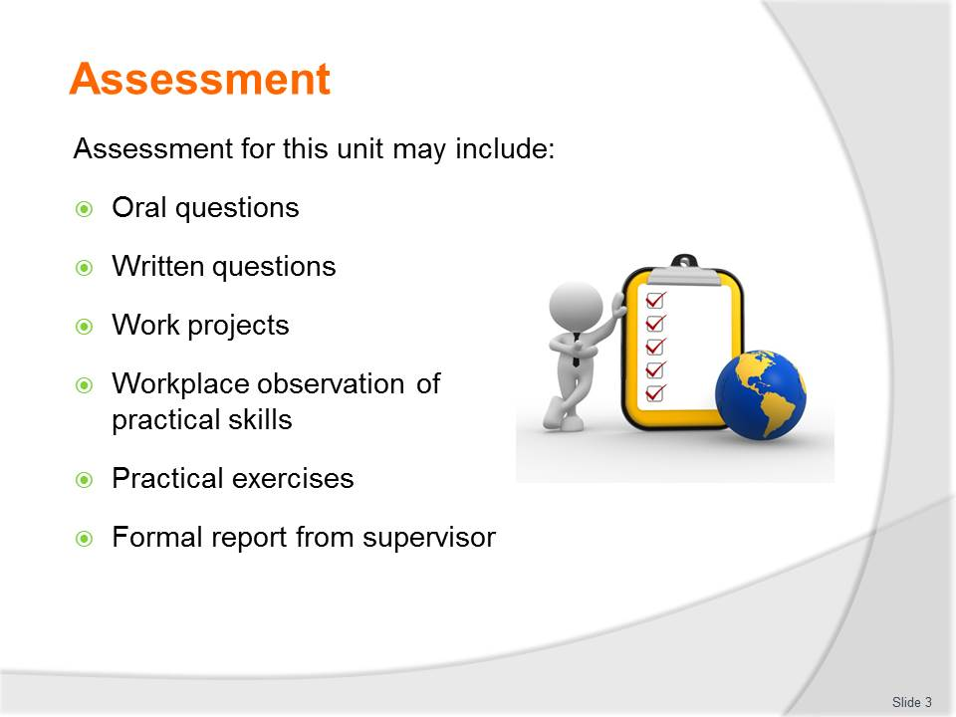
Slide No | Trainer Notes
Trainer advises that assessment for this Unit may take several forms all of which are aimed at verifying they have achieved competency for the Unit as required.
Trainer indicates the methods of assessment that will be applied to them for this Unit.

Slide
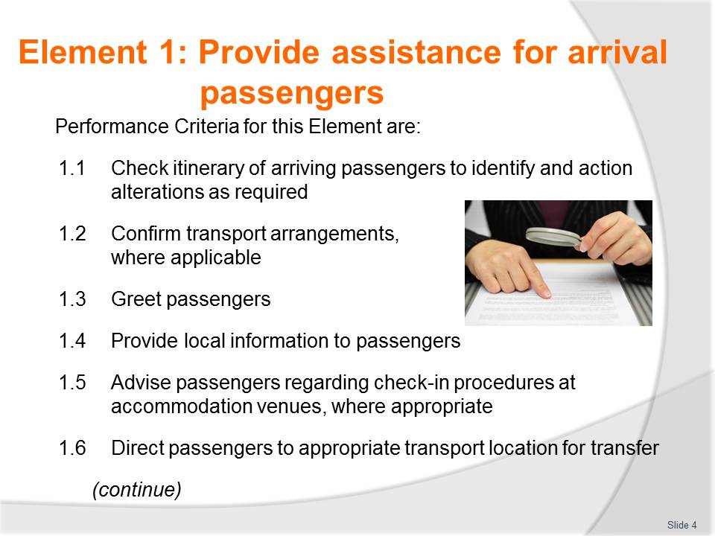
Slide No | Trainer Notes
 | Trainer identifies the Performance Criteria for this Element, as listed on the slide.

Slide
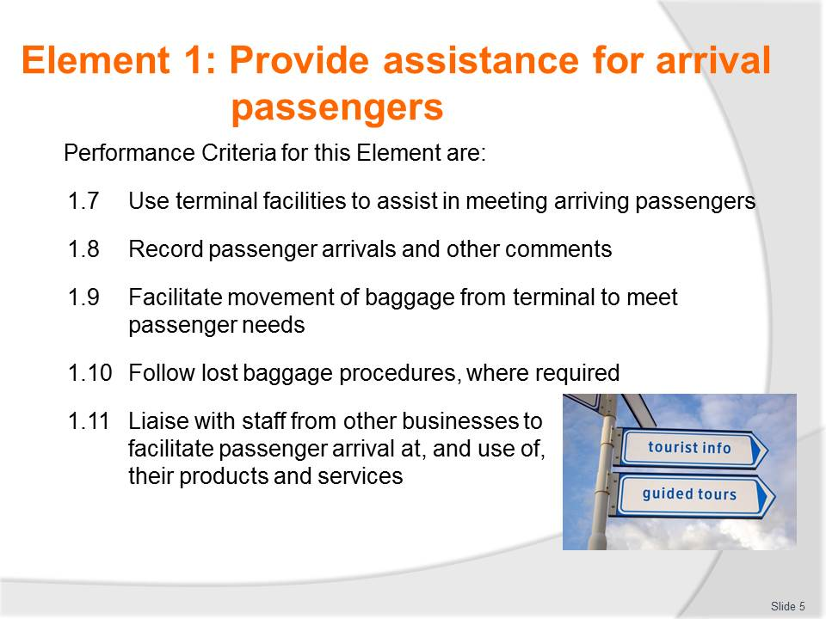
Slide No | Trainer Notes
 | Trainer identifies the Performance Criteria for this Element, as listed on the slide.

Slide
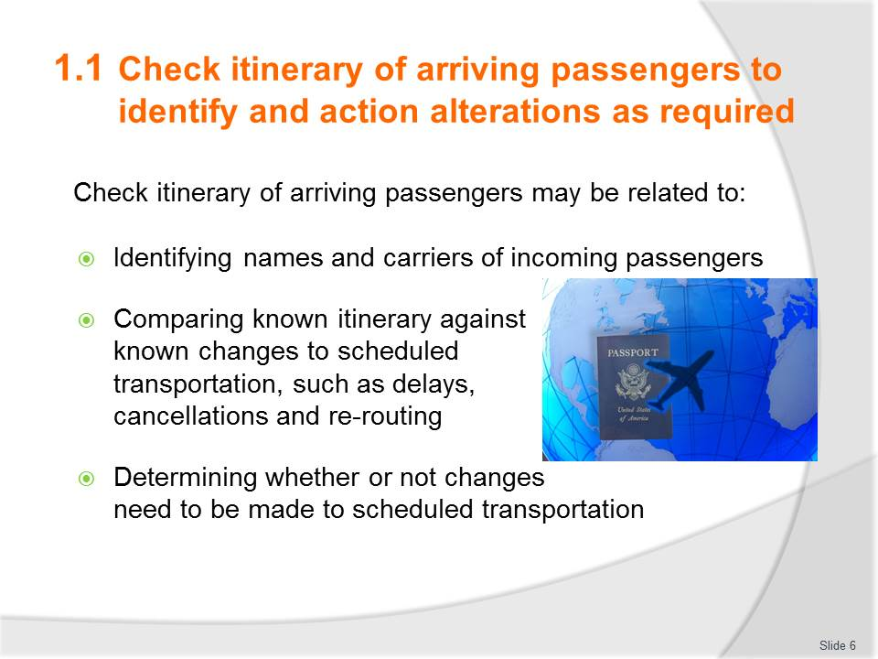
Slide No | Trainer Notes
 | Brainstorm each point within small groups providing 1 – 2 examples or brainstorm as a class incorporating personal experience or knowledge of similar situations.

Slide
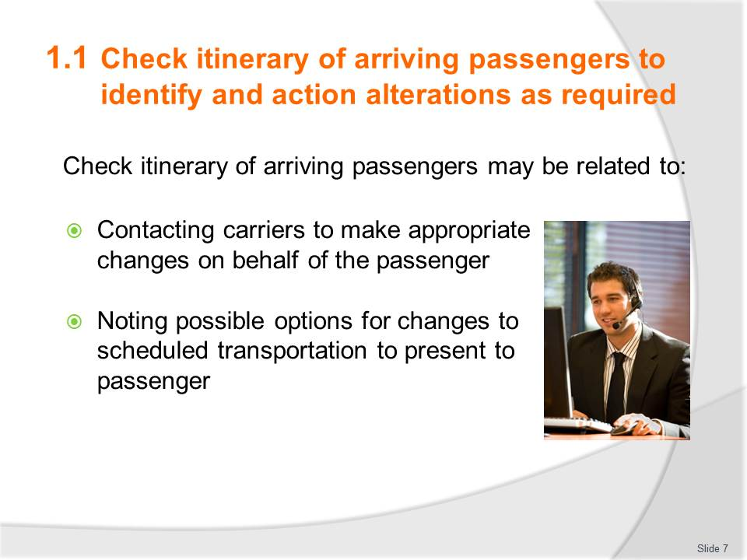
Slide No | Trainer Notes
 | Brainstorm each point within small groups providing 1 – 2 examples or brainstorm as a class incorporating personal experience or knowledge of similar situations.

Slide
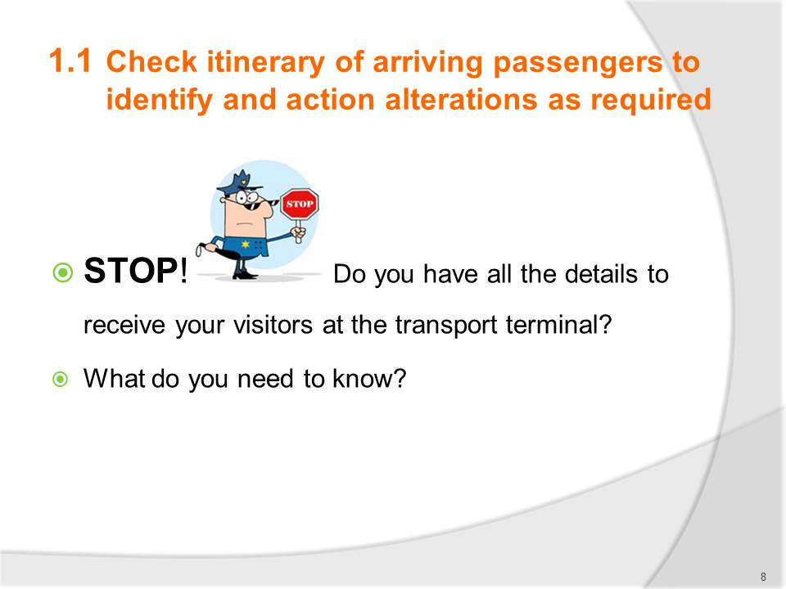
Slide No | Trainer Notes
Brainstorm this to encourage participation and engagement in the topic. Emphasise the importance of arriving prepared.
Answers on next slide.

Slide
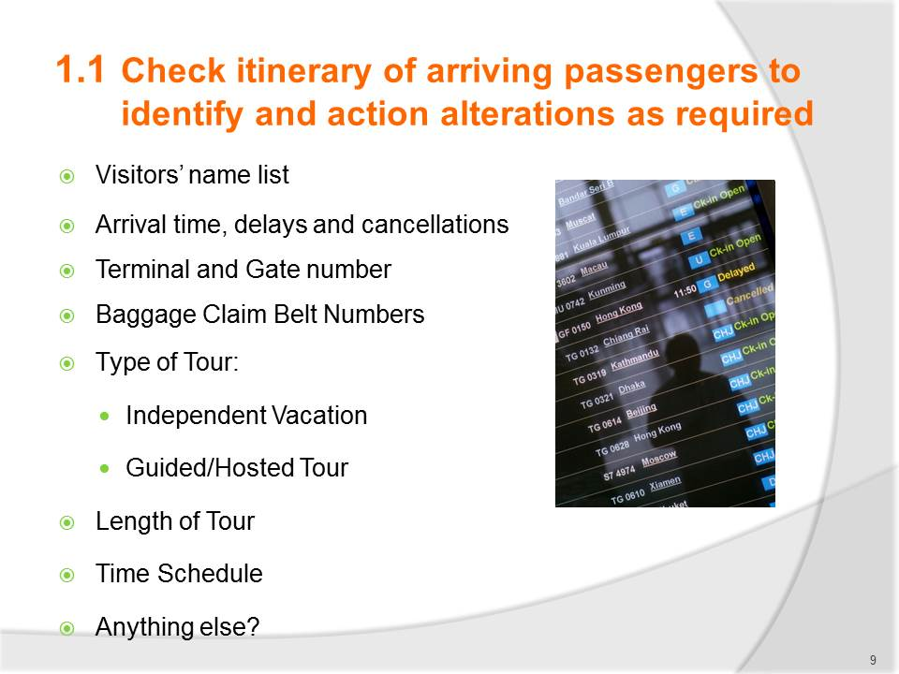
Slide No | Trainer Notes
 | Check for any other good suggestions by learners.

Slide
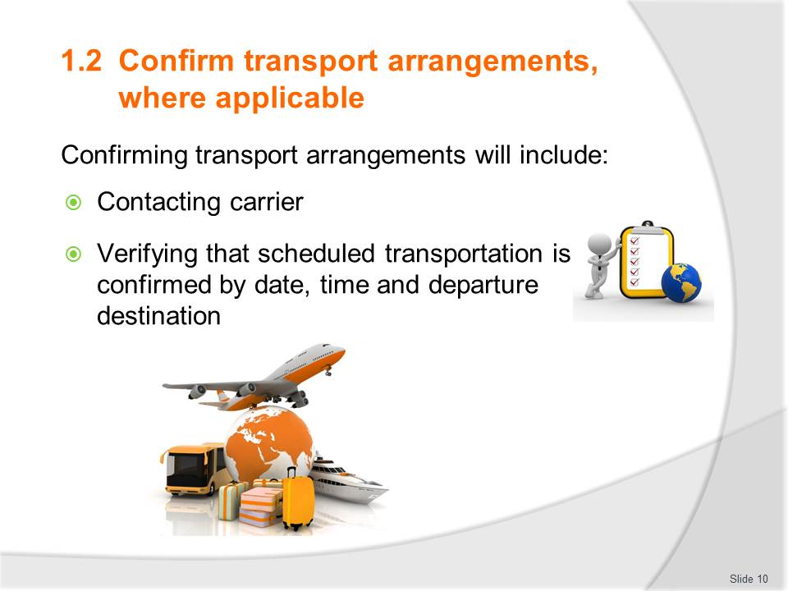
Slide No | Trainer Notes
 | Discuss what needs to be talked through for each of these points.

Slide
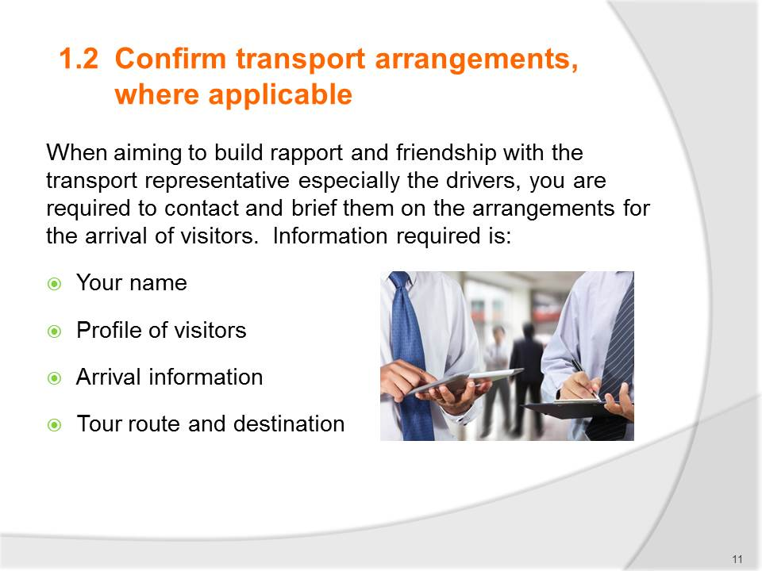
Slide No | Trainer Notes
Discuss why each of these points is important. (Continue on next slide as well)
Discuss and brainstorm in further detail what details can be raised with bullet points 2 - 4.
Your name – your full name, present business card, inform of abbreviated or other name you may prefer to be known as:
- Profile of visitors – who the travellers are today, ethnicity, age group, destination preferences, length of stay…..
- Arrival information – arrival, confirm accommodation location
- Tour route and destination – confirming best route for travel and both be agreeable on this.

Slide
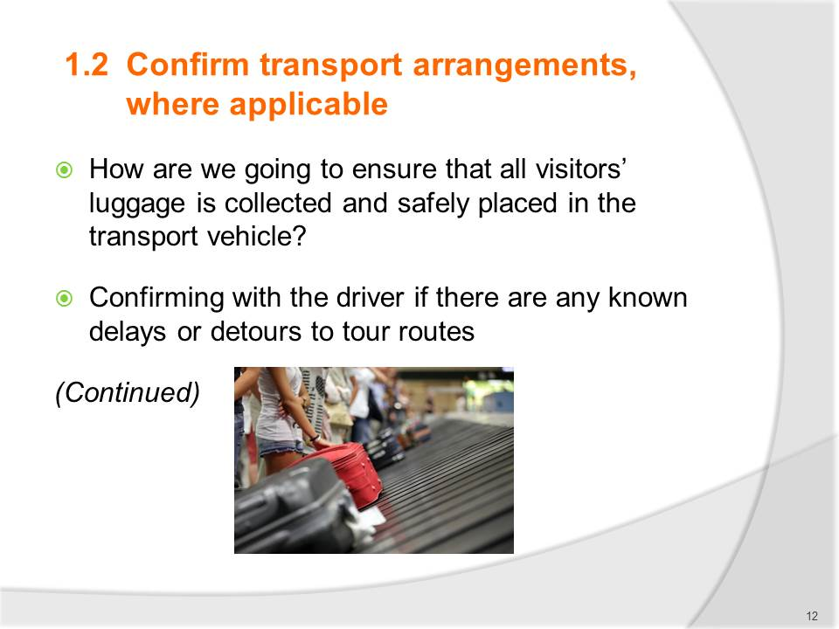
Slide No | Trainer Notes
 | Discuss why each of these points is important.

Slide
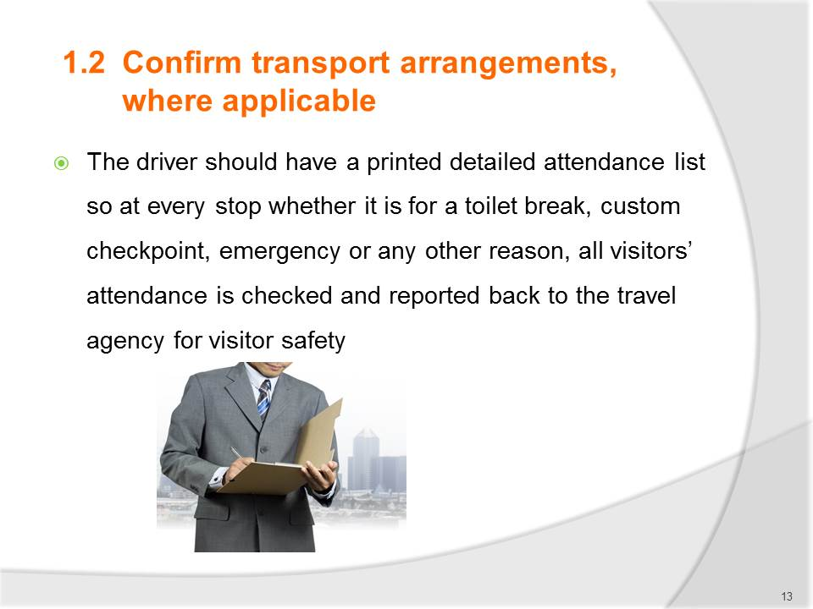
Slide No | Trainer Notes
 | Discuss why this point is important.

Slide
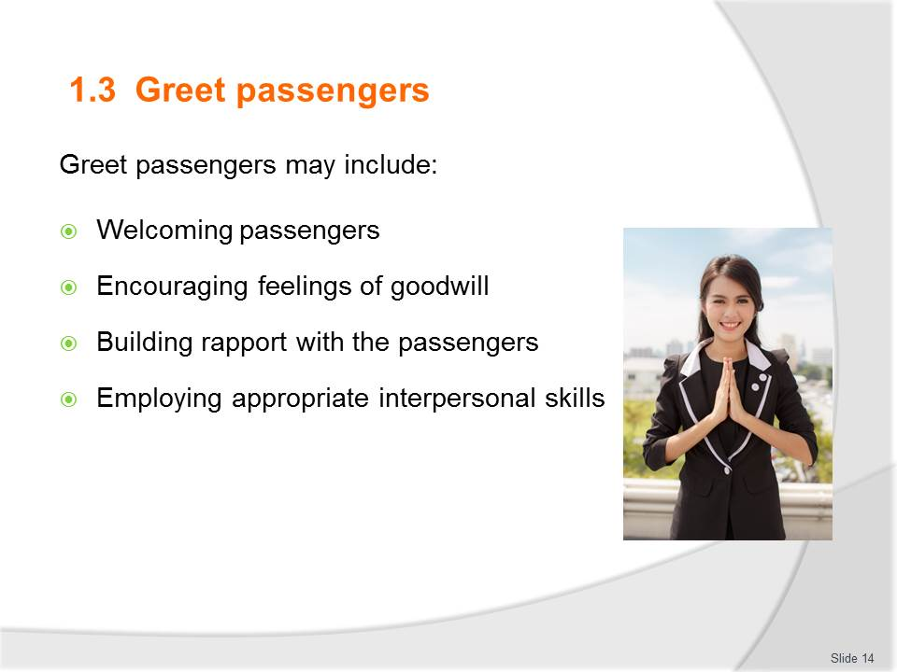
Slide No | Trainer Notes
Discuss the importance of this and the impact the greeting may have on the overall mind set of customers.
Use the acronym ‘GST’ (greet, smile, thank)as a memory training tool.
Ensure trainees understand ‘rapport’ and ‘interpersonal’ skills.
Discuss grooming and dress – what is appropriate (may have already covered this several times in other units).
Discuss body language and voice control.
Indicate to learners that they will now be asked to demonstrate how they will greet their passengers.
Activity – Greet Passengers allow 15-30 depending how in-depth. Could be done within groups, or to the class.

Slide
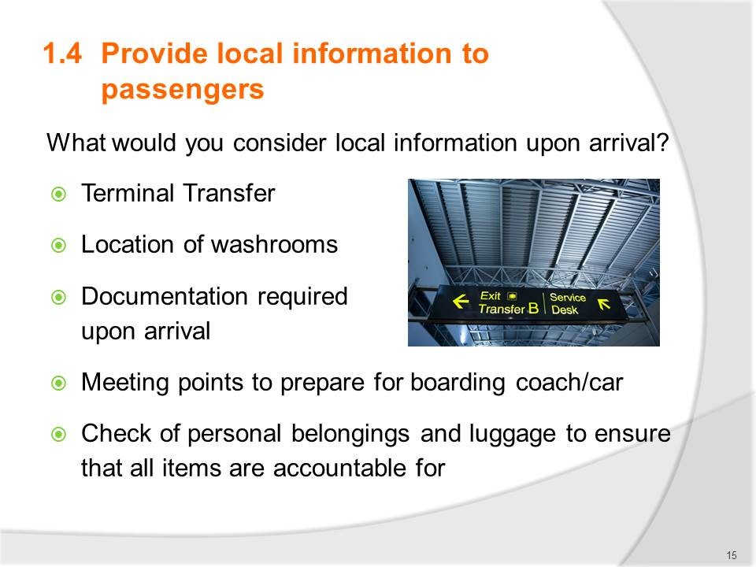
Slide No | Trainer Notes
The Trainee manual reflects some key points for discussion upon first meeting visitors.
There is animation on bullet points. Answers will ‘fade in’
Brainstorm or small groups to provide suggestions before revealing answers.
Discuss trainee answers further as needed.

Slide
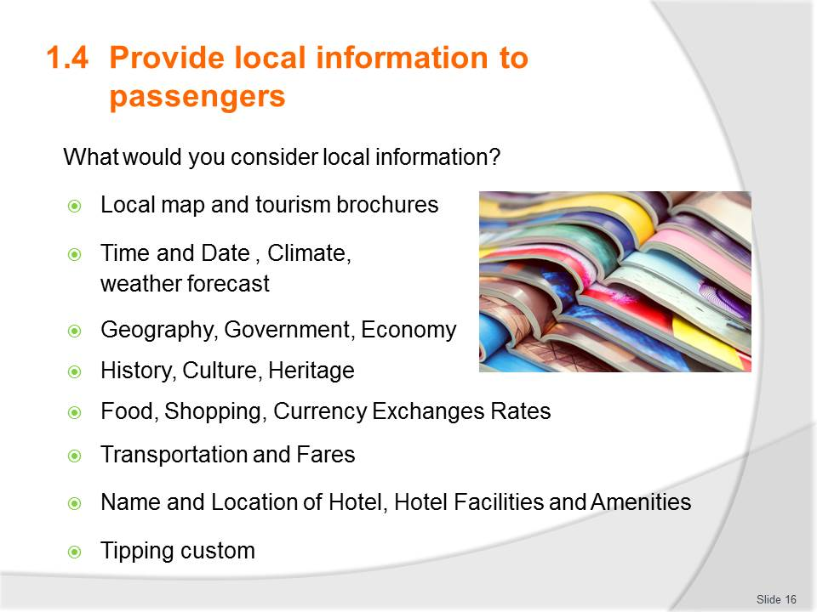
Slide No | Trainer Notes
There is animation on bullet points. Answers will ‘fade in’.
In small groups use flip charts to create a list. Each group to present their thoughts. Discuss and review as needed.

Slide
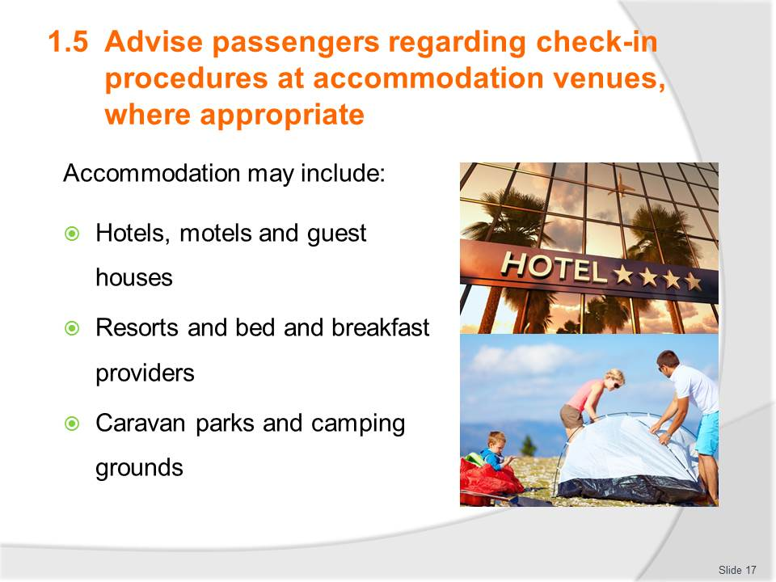
Slide No | Trainer Notes
 | Discuss learners understanding of each type of accommodation before referring to notes. Not all accommodation is popular or available in Asia.

Slide
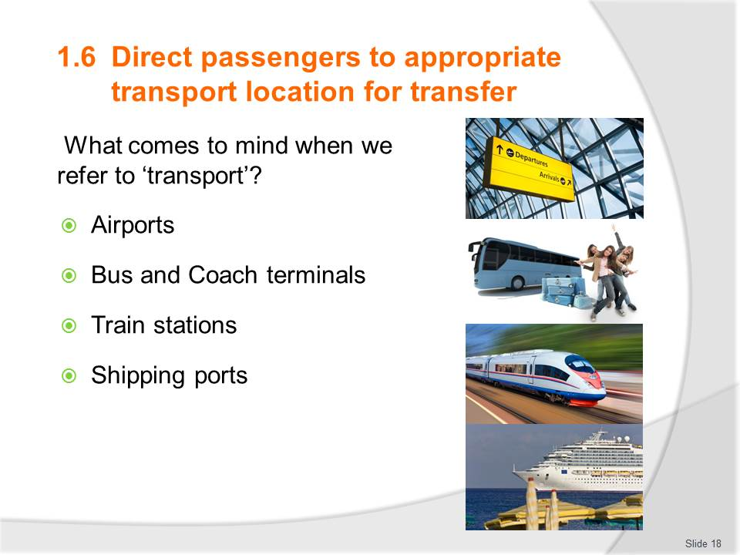
Slide No | Trainer Notes
There is animation on bullet points. Answers will ‘fade in’.
Based on location for training learners may have quite varied experience with each point. Discuss this and the size of the transport terminal they are familiar with. I.e. Capital city, major town or village. Perhaps discuss some of the busiest transport terminals in the world:
- Airports – JFK, Heathrow
- Cruise ports – Spain, Italy, Florida-USA, Caribbean, Mexico, Singapore
- Train stations – All major Stations in Japan, Gare du Nord, France, Penn Station New Jersey, USA, Zurich Station Switzerland, Union Station Canada
- Bus Stations – see website http://nobert-bermosa.blogspot.com.au/2011/08/world-record-holders-most-remarkable.html.

Slide
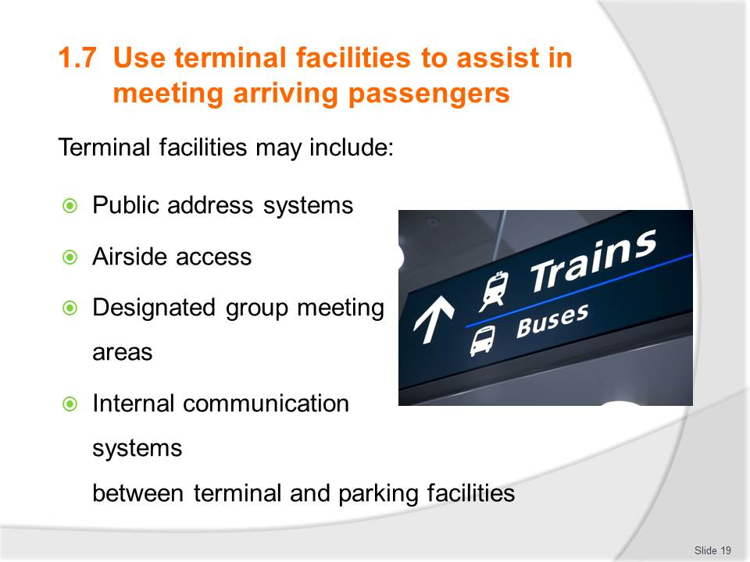
Slide No | Trainer Notes
Discuss and confirm understanding of each point.
If possible allow trainees to experience speaking into a microphone or megaphone.
Alternatively discuss do’s and don’ts when the voice is amplified.
Discuss each point based on knowledge and experience. Seek input from learners on previous experience.

Slide
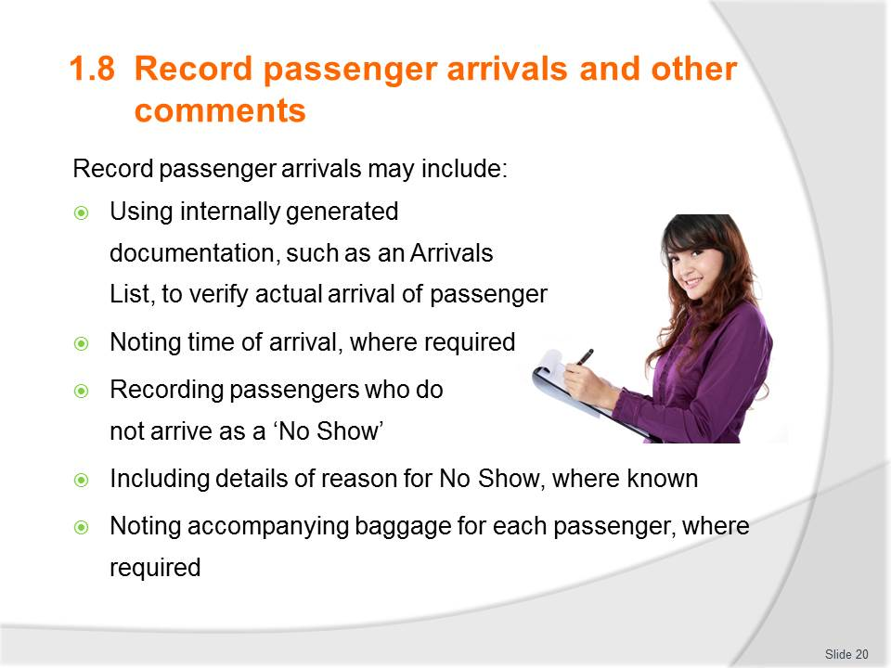
Slide No | Trainer Notes
Discuss as needed identifying key points and their importance.
Where possible have a sample of an Arrivals List for viewing.

Slide
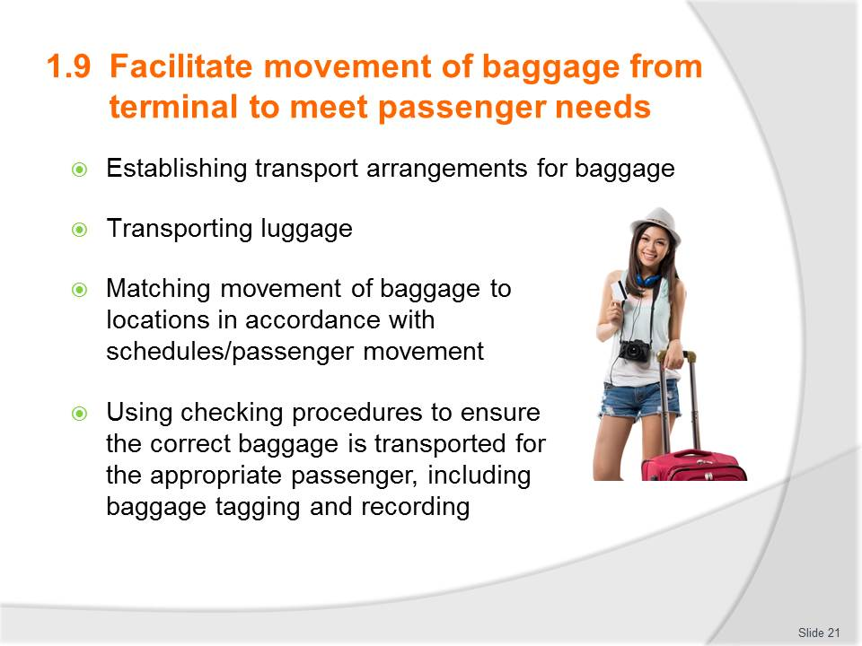
Slide No | Trainer Notes
Discuss each point and its importance or relevance. Link back to the Arrivals list where the pieces of luggage are listed as well.
Information on a luggage tag: (if possible have luggage tag samples available)
- Agency name and contact details
- Colour codes for specific purposed(these may vary depending on tour operator)
- Name of visitor
- Destination for luggage to be transported to
- Special requirements such as ‘Fragile – Handle me with care’, ‘Heavy’ notifications.
For bullet point #2 ensure an understanding of carry-on luggage allowances and why they are limited. Importance of declaring fragile items and what would come under miscellaneous fees.

Slide
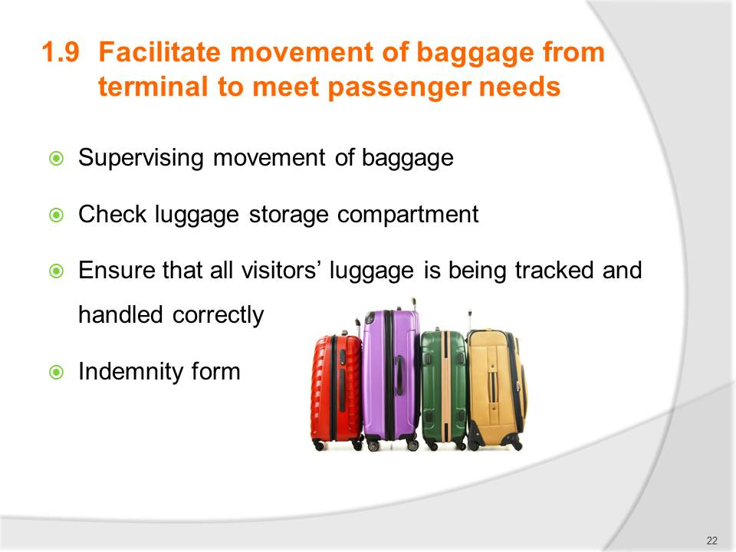
Slide No | Trainer Notes
Discuss each as needed
Luggage tracking – computerised methods available today utilizing barcodes. Reminder that it is the Tour Guide’s responsibility to double check all luggages is accounted for before the transport driver departs or the Bell Attendant transfers to rooms.
Have a sample ‘indemnity form’ for viewing. Discuss and identify its importance.

Slide
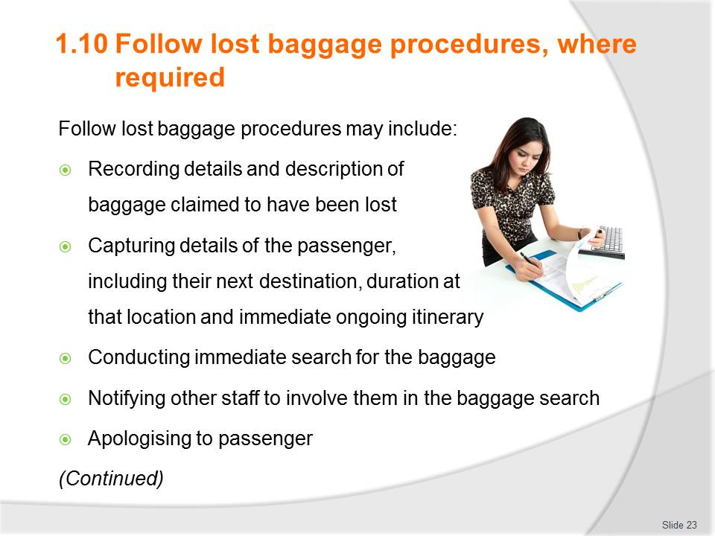
Slide No | Trainer Notes
Discuss: there are many points that may need to be covered with the passenger depending on your company policy so it is important to be familiar with it.
Is there any experience in the room regarding lost luggage? Was it found? How were you looked after?
Indicate that we will now look at a few points in more detail. Trainer to decide on which points and how many based on time allowance.

Slide
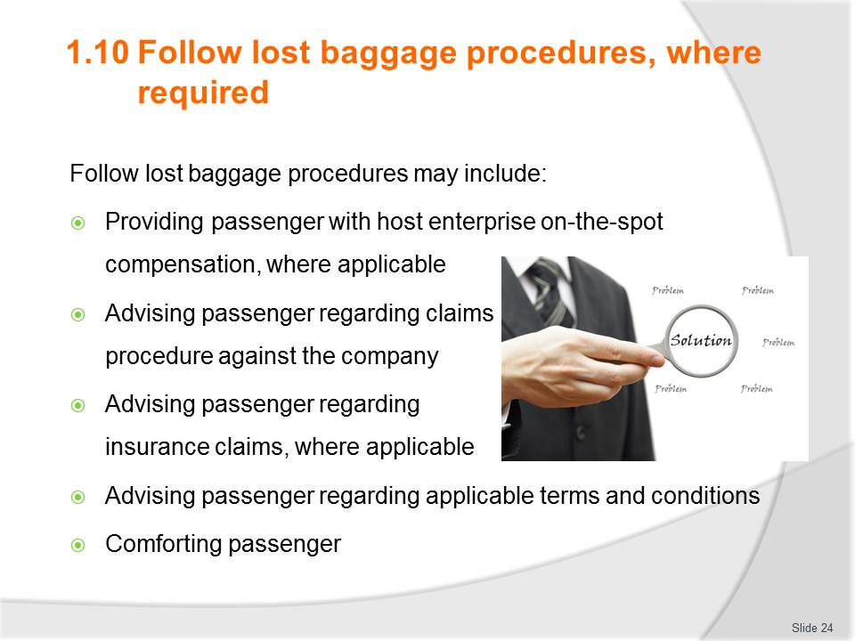
Slide No | Trainer Notes
Discuss: there are many points that may need to be covered with the passenger depending on your company policy so it is important to be familiar with it.
Is there any experience in the room regarding lost luggage? Was it found? How were you looked after?
Indicate that we will now look at a few points in more detail. Trainer to decide on which points and how many based on time allowance.

Slide
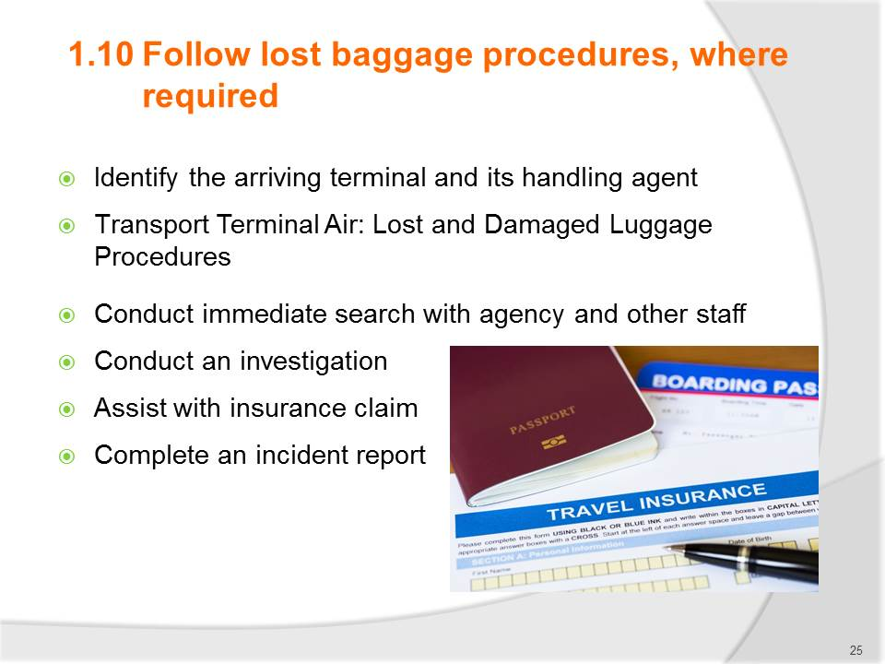
Slide No | Trainer Notes
What is the role of a Handling Agent
- Review samples of Lost luggage procedure from Changi airport in Trainee manual
- Identify limitations for passengers regarding baggage liability in manual
- Discuss what may be involved in a search and the importance of taking notes and names of staff in order to complete an investigation and incident report.
- If possible have a sample of ‘Incident Report’ for viewing. This could be made an activity where small groups need to role play the situation.

Slide
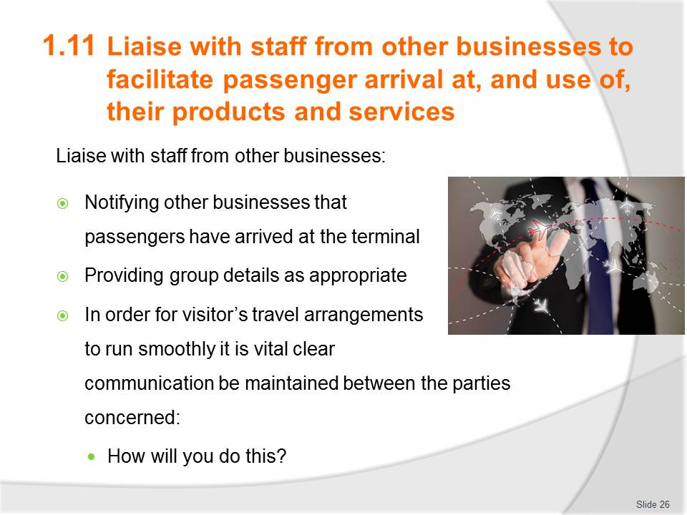
Slide No | Trainer Notes
Discuss types of businesses this would involve and the different details they may require to provide the product or service ordered.
This could be made an activity where small groups need to identify an arrival situation (elderly tour group, private family group, business group or other) and detail their communications and present to the class. Emphasise this type of presentation assists with gaining experience in announcing or providing information in a group situation.
Complete Work Projects for this Element from Trainee Manual as time allows either individually or in work groups. If no time then direct learners to complete as homework.

Slide
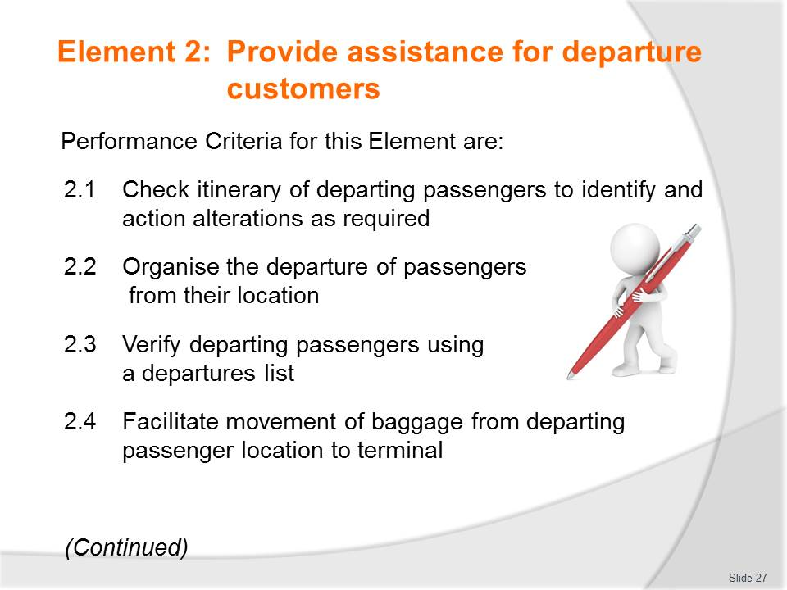
Slide No | Trainer Notes
 | Trainer identifies the Performance Criteria for this Element, as listed on the slide.

Slide
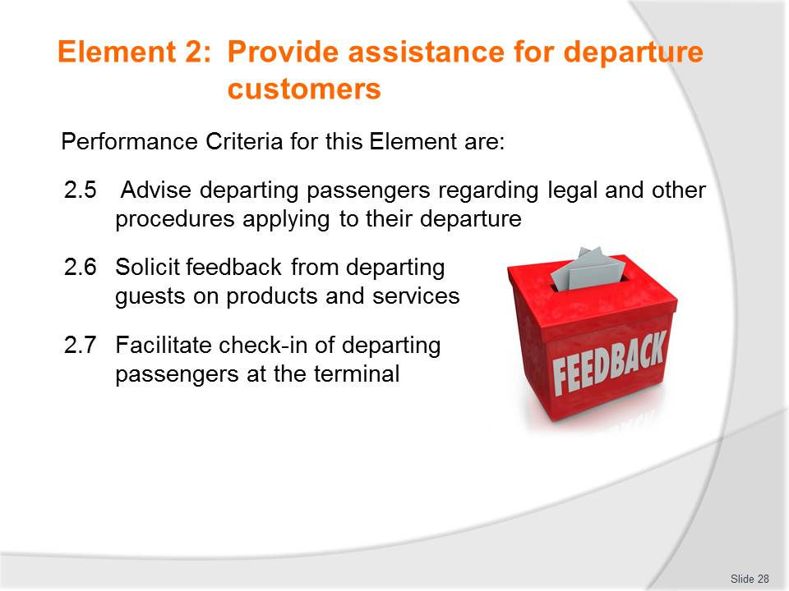
Slide No | Trainer Notes
 | Trainer identifies the Performance Criteria for this Element, as listed on the slide.

Slide
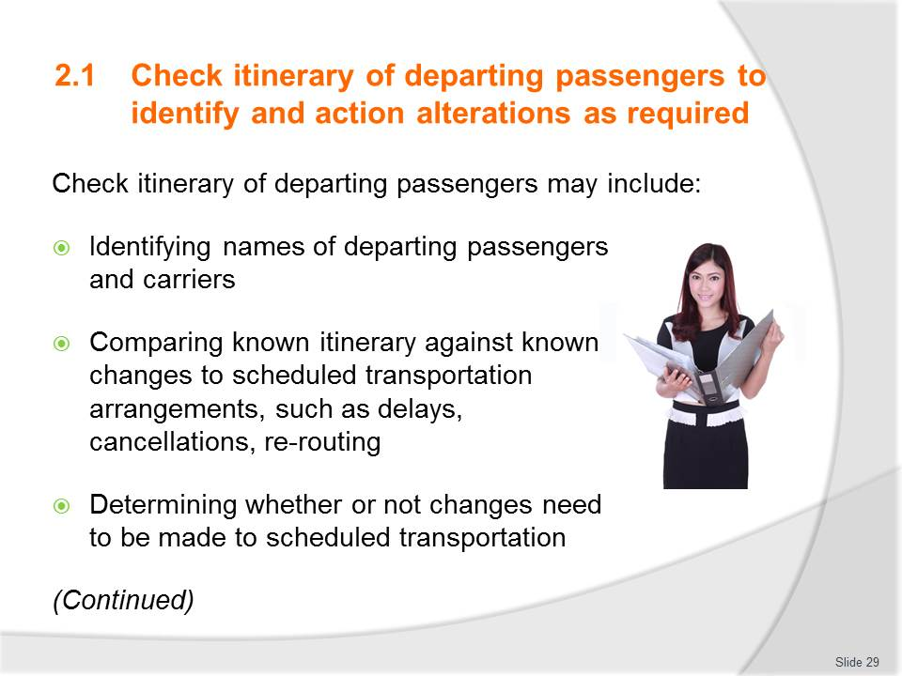
Slide No | Trainer Notes
 | Discuss points (continued on next slide) as time allows. This could be done as an activity. Divide class into small groups. Each group to work through bullet points providing information, samples, options as required for each point. The purpose is to have scenarios where changes need to or must be changed and learners are to provide solutions.

Slide
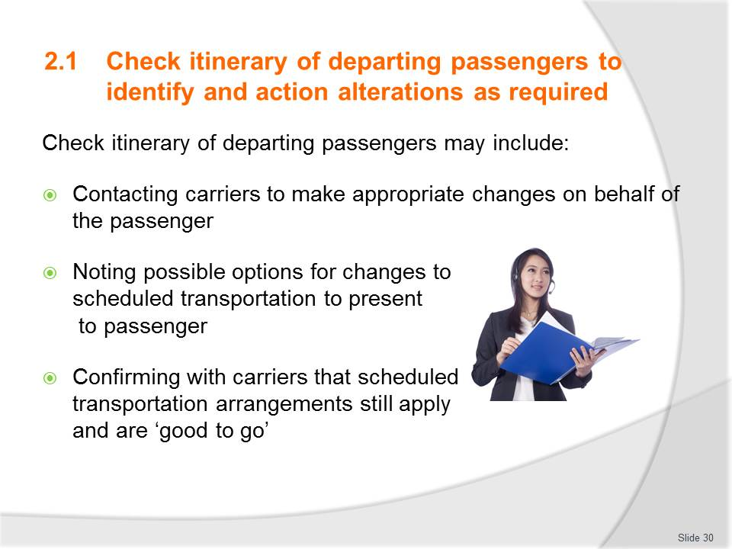
Slide No | Trainer Notes
 | Work through each of these points to confirm participant comprehension.

Slide
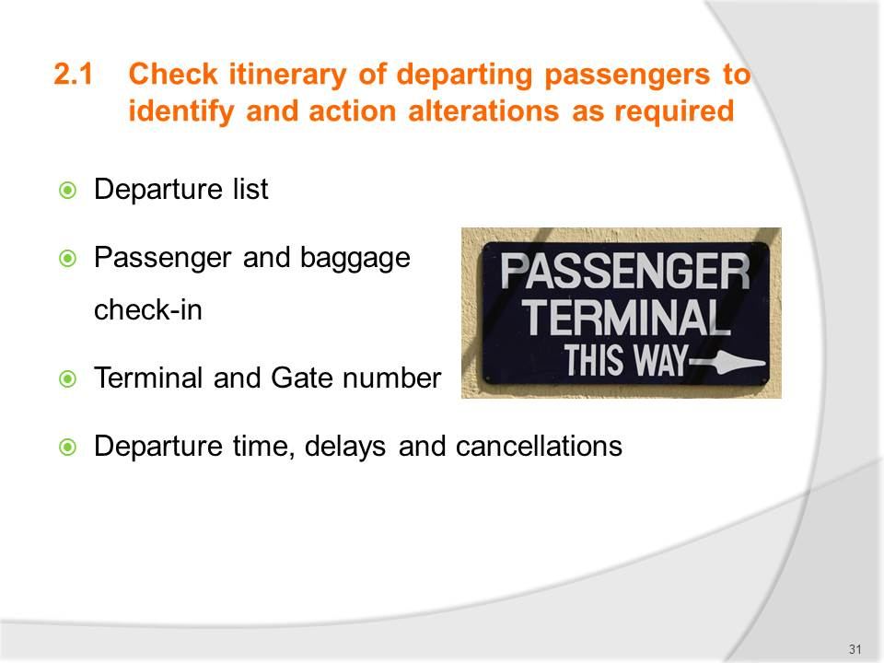
Slide No | Trainer Notes
Discuss what would be checked and confirmed before meeting departing visitors.
Case Scenario:
A group of 28 pax from ABC Travel are spending their last two nights at Furama Riverfront Hotel. Michael Yeo is the tour agent representing the agency and he has been with the visitors for the past three days. They are now on their last two nights; Michael has to check and prepare several arrangements before the departure.
Based on this scenario, you are to answer all of the following questions.
Question 1: Design a flow chart for all procedures required when preparing for departure of visitors.
Question 2: Explain the importance of such preparation and list the personnel to collaborate with.
Question 3: List three possible issues faced while preparing for departure of visitors.
Possible answer Q2:
- Being prepared or preparation plan before executing, will benefit your professionalism and company brand. “Good Customer Service” principle is the first and last impression last.
Possible answer Q3:
- Flight delay due to unforeseen circumstances and Visitors will be stranded in Airport
- No Transportation available due to festive seasons
- High volume turnover at the Hotel where they could not accommodate late check-out.

Slide
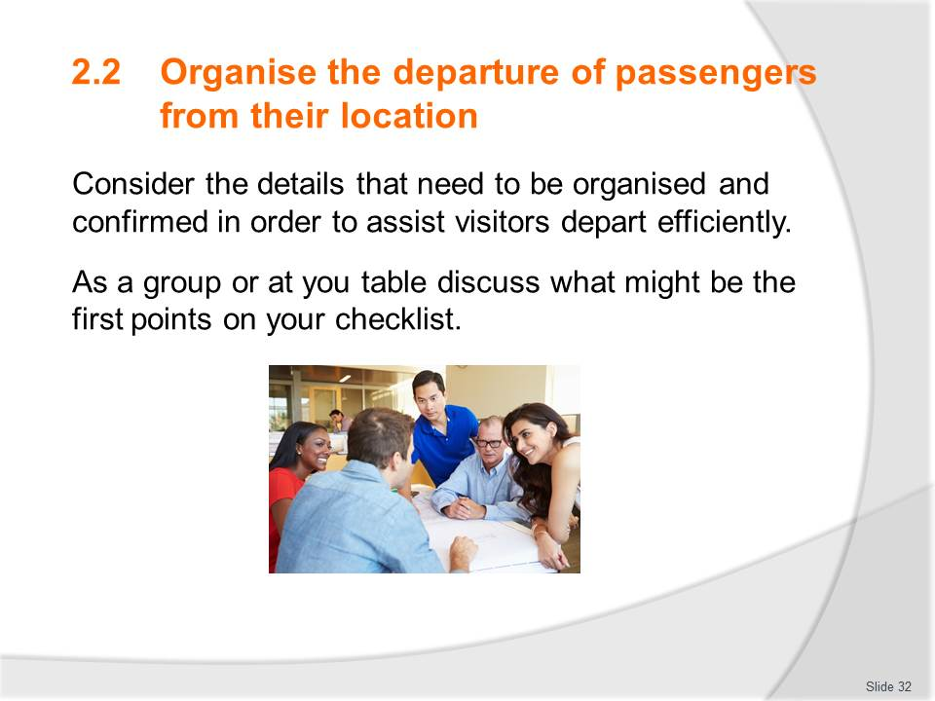
Slide No | Trainer Notes
Activity
Learners are to arrange a checklist of details simulating organising passenger departure.
Trainer to indicate the following details specific to the country location you are in:
- A flight and destination. Day and date
- Number of passengers (pax)
- A hotel
- Briefing notes for passengers on transfer details (utilise trainee manual notes)
- Trainees are to present to the class/remainder of their work group.
Trainer may choose to make this simple or more detailed depending on group size and time available. This activity can be combined with Trainee Manual role play for this Performance Criteria.

Slide
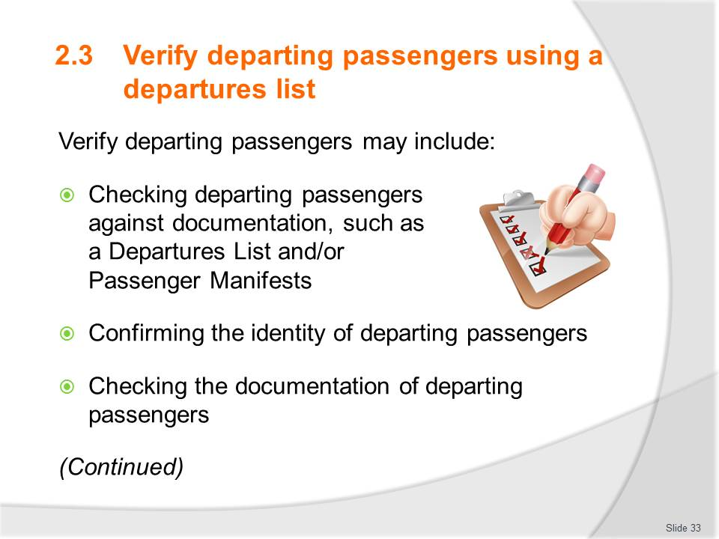
Slide No | Trainer Notes
The organising of the guest has been completed now the Departures List needs to be verified:
- Departure list
- Identity, documents and luggage
- Conduct a manual head count
- Itinerary update.
Activity – GROUP DISCUSSION (from Trainee Manual)
Instructions: Ask learners to divide into 2-3 groups of 6-10. Work onto a flip chart or whiteboard so everyone is involved
Question: What questions, concerns or issues might be faced by the visitors and the tour operators when verifying departing passengers? Identify 4 and their solutions.
Purpose: To encourage learners to exercise their on–the-spot problem solving skills.

Slide
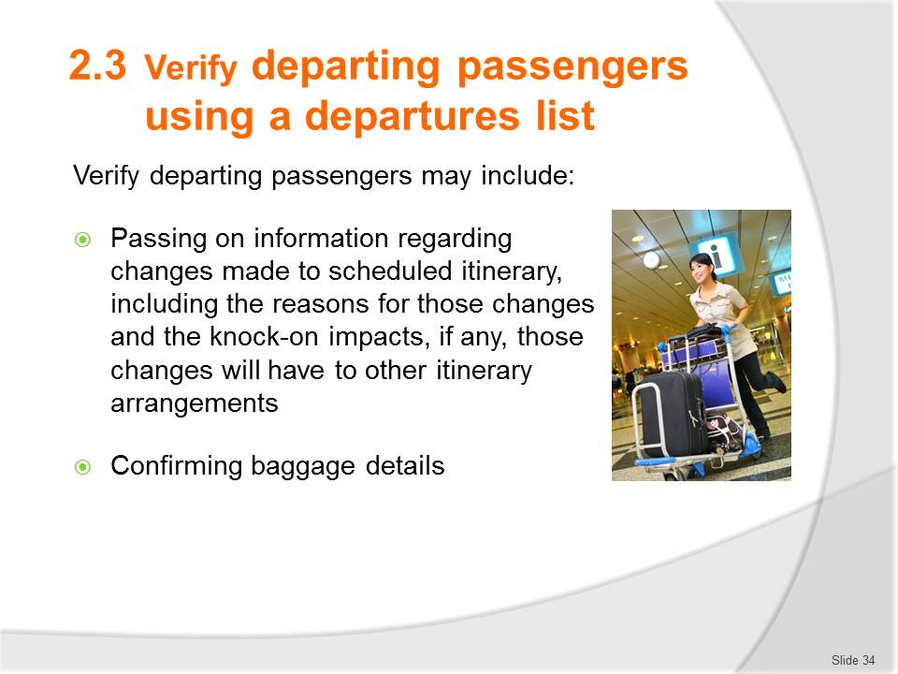
Slide No | Trainer Notes
The organising of the guest has been completed now the Departures List needs to be verified:
- Departure list
- Identity, documents and luggage
- Conduct a manual head count
- Itinerary update.
Activity – GROUP DISCUSSION (from Trainee Manual)
Instructions: Ask learners to divide into 2-3 groups of 6-10. Work onto a flip chart or whiteboard so everyone is involved
Question: What questions, concerns or issues might be faced by the visitors and the tour operators when verifying departing passengers? Identify 4 and their solutions.
Purpose: To encourage learners to exercise their on–the-spot problem solving skills.

Slide
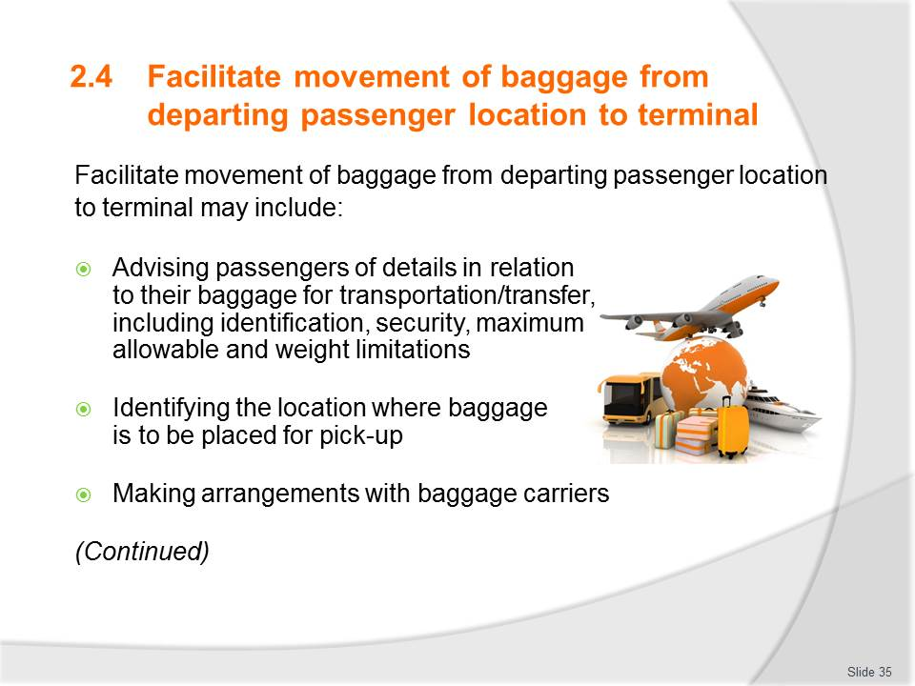
Slide No | Trainer Notes
What details do you need to have considered for baggage transfer?
Ask trainees to close their manuals and ask a volunteer from each group to write one detail on the whiteboard that requires confirming with the baggage carrier. Go around the room adding one at a time. Watch the list grow on the board.
Discuss other points from power point as needed and time allows.

Slide
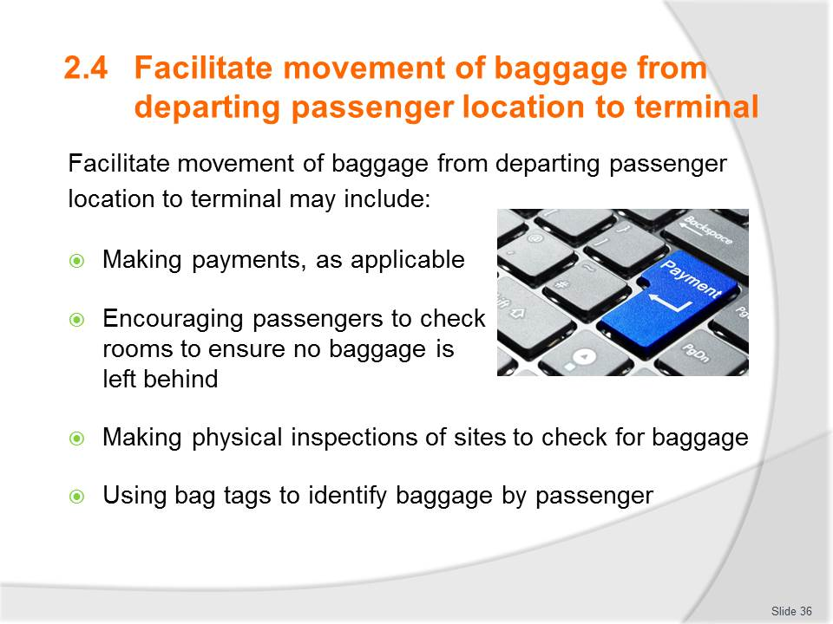
Slide No | Trainer Notes
What details do you need to have considered for baggage transfer?
Ask trainees to close their manuals and ask a volunteer from each group to write one detail on the whiteboard that requires confirming with the baggage carrier. Go around the room adding one at a time. Watch the list grow on the board.
Discuss other points from power point as needed and time allows.

Slide
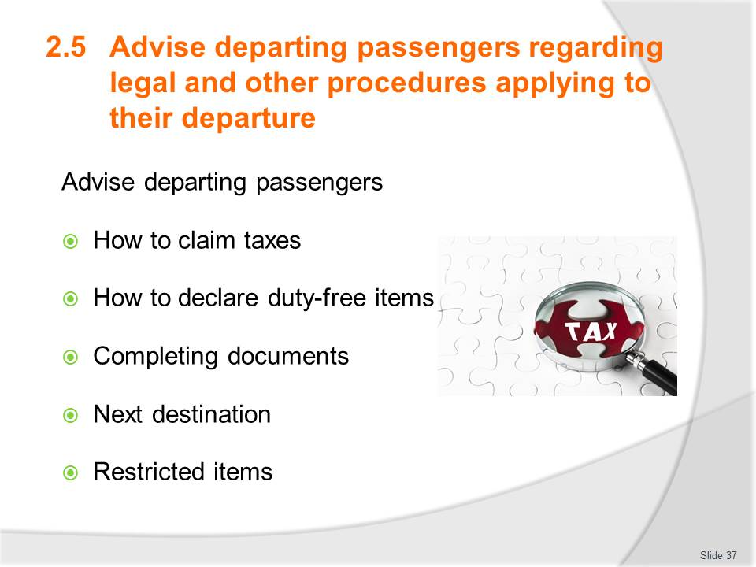
Slide No | Trainer Notes
Allocate one of the following to each group and ask them to search what applies to your country or location. Perhaps they can search using their phones or library computers. This could be compared against what applies in a neighbouring country:
- Which document must be completed
- How to claim taxes
- Restricted items.
Discuss the findings so learners have knowledge of each.

Slide
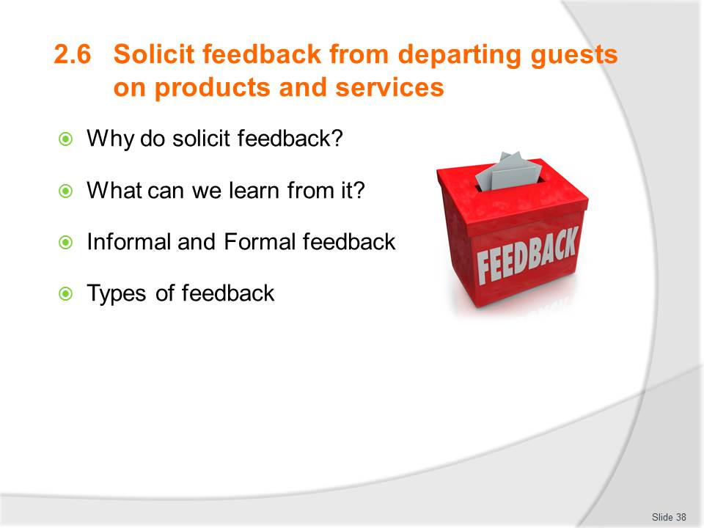
Slide No | Trainer Notes
Discuss the first two points and note down what we can learn.
Check understanding of Formal and Informal feedback and the effectiveness of each.
Discuss positives and negatives of types of feedback.
Practically everyone has been asked to provide feedback on a product or service at some stage. Learners to share any personal experiences that may be relevant.

Slide
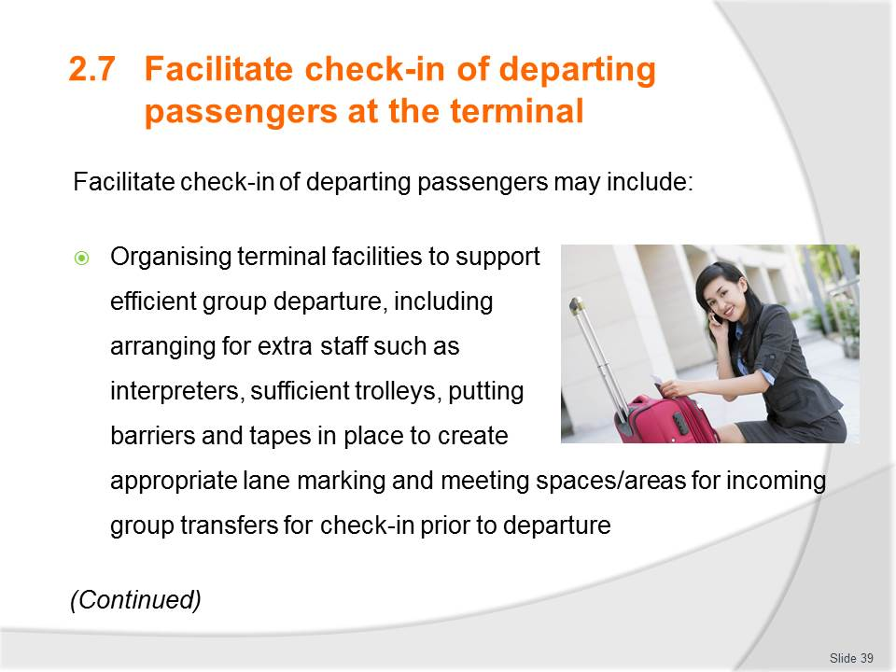
Slide No | Trainer Notes
Discuss each point relating to your current country or location.
Inexperienced travellers may need deeper clarification of this process.
Complete the activity below
Activity – GROUP DISCUSSION (from Trainee Manual)
Instructions: Ask learners to divide into 2-3 groups of 6-10. Work onto a flip chart or whiteboard so everyone is involved and develop a checklist of steps and processes required for checking in visitors at the transport terminal (note; this could be air, sea, rail, coach). Scenario begins at the point of the transfer transport arriving at the departing terminal.
Could allocate a different scenario for each work group. Private family tour 2 adults 2 kids travelling to New Zealand, Guided tour group of 20 European business visitors returning to their home countries of France, Germany, Italy. A tour group of 36 elderly Americans returning home to Florida, Family group consisting of 3 families. 6 adults 9 kids ages 3-15 travelling to Mexico.
Purpose: To establish learners’ current knowledge of practices at their workplace and tie in with the PC 2.7
Duration: 15 mins to discuss and present for each group.
Now that all of the visitors are being transported to the transport terminal, you are now to check them in at the respective counter. Before proceeding, do one last headcount to ensure all are there with their personal belongings.
Complete Work Projects for this Element from Trainee Manual as time allows either individually or in work groups. If no time then direct learners to complete as homework.

Slide
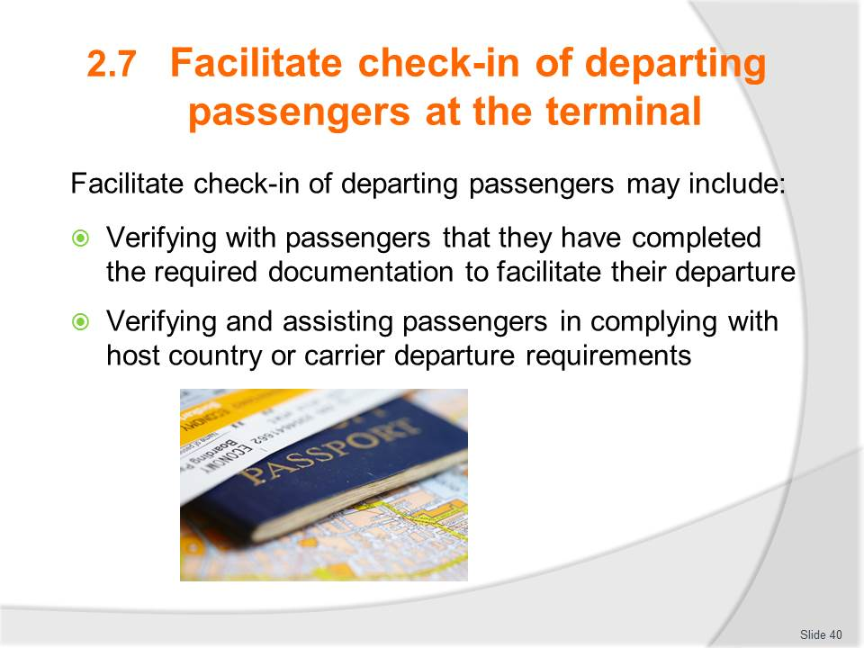
Slide No | Trainer Notes
Discuss each point relating to your current country or location.
Inexperienced travellers may need deeper clarification of this process.
Complete the activity below
Instructions: Ask learners to divide into 2-3 groups of 6-10. Work onto a flip chart or whiteboard so everyone is involved and develop a checklist of steps and processes required for checking in visitors at the transport terminal (note; this could be air, sea, rail, coach). Scenario begins at the point of the transfer transport arriving at the departing terminal.
Could allocate a different scenario for each work group. Private family tour 2 adults 2 kids travelling to New Zealand, Guided tour group of 20 European business visitors returning to their home countries of France, Germany, Italy. A tour group of 36 elderly Americans returning home to Florida, Family group consisting of 3 families. 6 adults 9 kids ages 3-15 travelling to Mexico.
Purpose: To establish learners’ current knowledge of practices at their workplace and tie in with the PC 2.7
Duration: 15 mins to discuss and present for each group.
Now that all of the visitors are being transported to the transport terminal, you are now to check them in at the respective counter. Before proceeding, do one last headcount to ensure all are there with their personal belongings.
Complete Work Projects for this Element from Trainee Manual as time allows either individually or in work groups. If no time then direct learners to complete as homework.

Recommended training equipment
- Accompaniments to travel documentation including:
- Agency branded voucher covers
- Agency branded itinerary covers
- Stationery with agency logo
- Wallets if available
- Baggage labels
- Extra information
- Business card
- Insurance policy
- Air travel documentation
- Computers - one for each participant
- Customer reservation sheets
- E-tickets
- Internet access
- Non-air travel documentation including:
- Accommodation vouchers
- Bus/coach or other forms of transportation tickets
- Car hire/motor home vouchers
- Cruise vouchers
- Tour vouchers
- Vouchers for attractions/theme park entry
- Vouchers for any tourism product or service
- Meeting or event confirmation letters
- Delegate information packs
- Travel insurance documentation
- Confirmation vouchers
- Visa forms
- Visas
- Passport forms
- Traveller’s cheque requests
- Passenger itineraries
- Operational itineraries for crews including tourist guides, drivers and tour managers
- Briefing notes for crews
- Passenger lists
- Rooming lists
- Pro-formas
- Sales returns
- Organisational Policies, procedures and standards
- Payment documentation and receipts
- Printers and paper
- Software systems manual
- Standard Operating Procedures (SOP's) based on using software systems
- Ticketing SOP's
- Various travel documentation associated with booking travel documentation, including airlines, tour operators, car hire and accommodation establishments
- Various stationery.

Instructions for Trainers for using
PowerPoint – Presenter View
Connect your laptop or computer to your projector equipment as per manufacturers’ instructions.
In PowerPoint, on the Slide Show menu, click Set up Show.
Under Multiple monitors, select the Show Presenter View check box.
In the Display slide show on list, click the monitor you want the slide show presentation to appear on.
Source: http://office.microsoft.com
Note:
In Presenter View:
You see your notes and have full control of the presentation
Your trainees only see the slide projected on to the screen
More Information
You can obtain more information on how to use PowerPoint from the Microsoft Online Help Centre, available at: http://office.microsoft.com/training/training.aspx?AssetID=RC011298761033
Note Regarding Currency of URLs
Please note that where references have been made to URLs in these training resources trainers will need to verify that the resource or document referred to is still current on the internet. Trainers should endeavour, where possible, to source similar alternative examples of material where it is found that either the website or the document in question is no longer available online.

Appendix – ASEAN acronyms
AADCP | ASEAN – Australia Development Cooperation Program
ACCSTP | ASEAN Common Competency Standards for Tourism Professionals
AEC | ASEAN Economic Community
AMS | ASEAN Member States
ASEAN | Association of Southeast Asian Nations
ASEC | ASEAN Secretariat
ATM | ASEAN Tourism Ministers
ATPMC | ASEAN Tourism Professionals Monitoring Committee
ATPRS | ASEAN Tourism Professional Registration System
ATFTMD | ASEAN Task Force on Tourism Manpower Development
CATC | Common ASEAN Tourism Curriculum
MRA | Mutual Recognition Arrangement
MTCO | Mekong Tourism Coordinating office
NTO | National Tourism Organisation
NTPB | National Tourism Professional Board
RQFSRS | Regional Qualifications Framework and Skills Recognition System
TPCB | Tourism Professional Certification Board





